Master Program On DevOps with AWS

==================================

Trainer : Mr. Ashok (9+ yrs Exp)

Current Role : Tech Lead

Skills : Java Fullstack Developer

Microservices

Angular

Linux, AWS and DevOps

Pre-requisites : Nothing

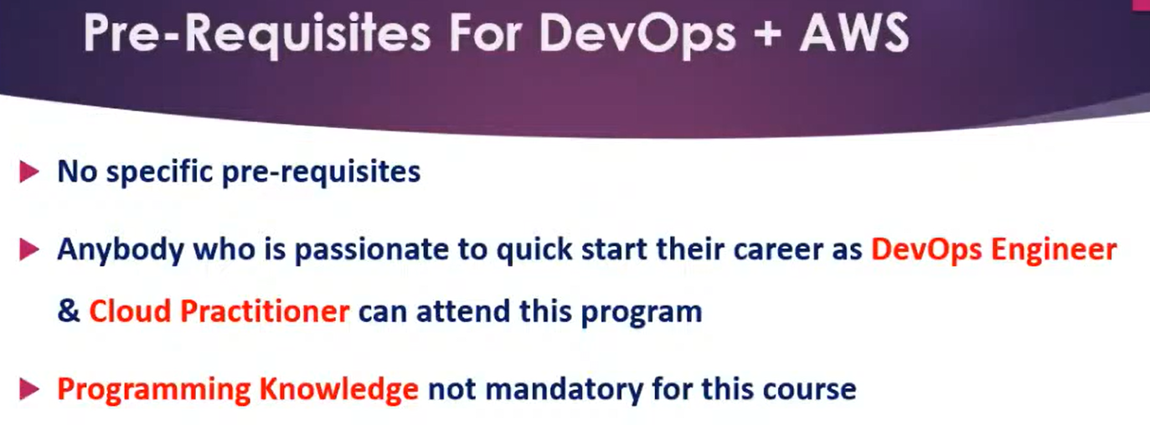

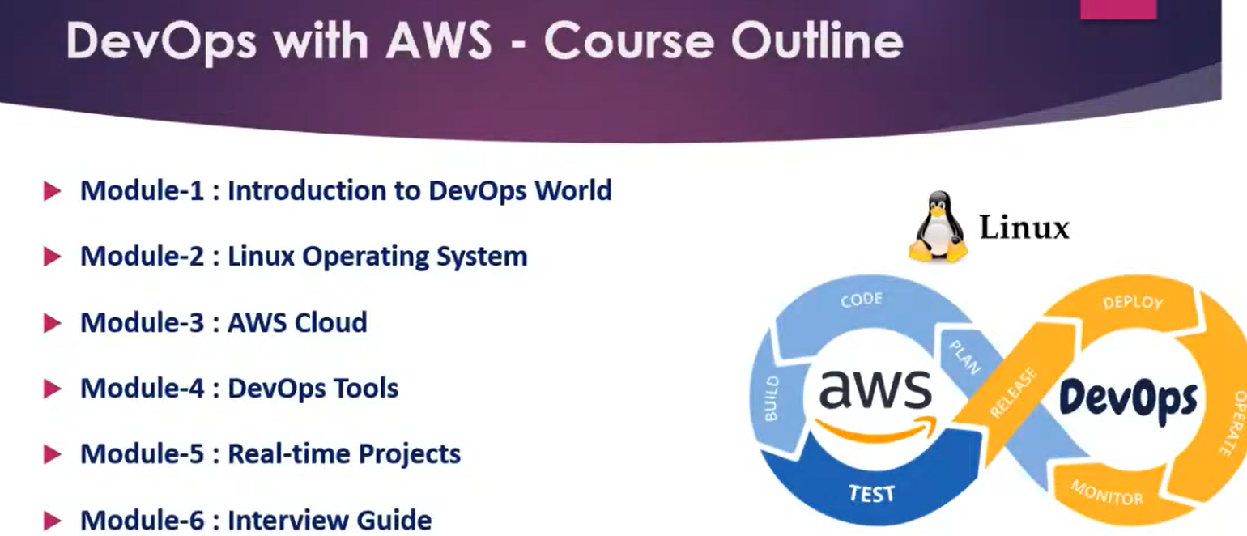

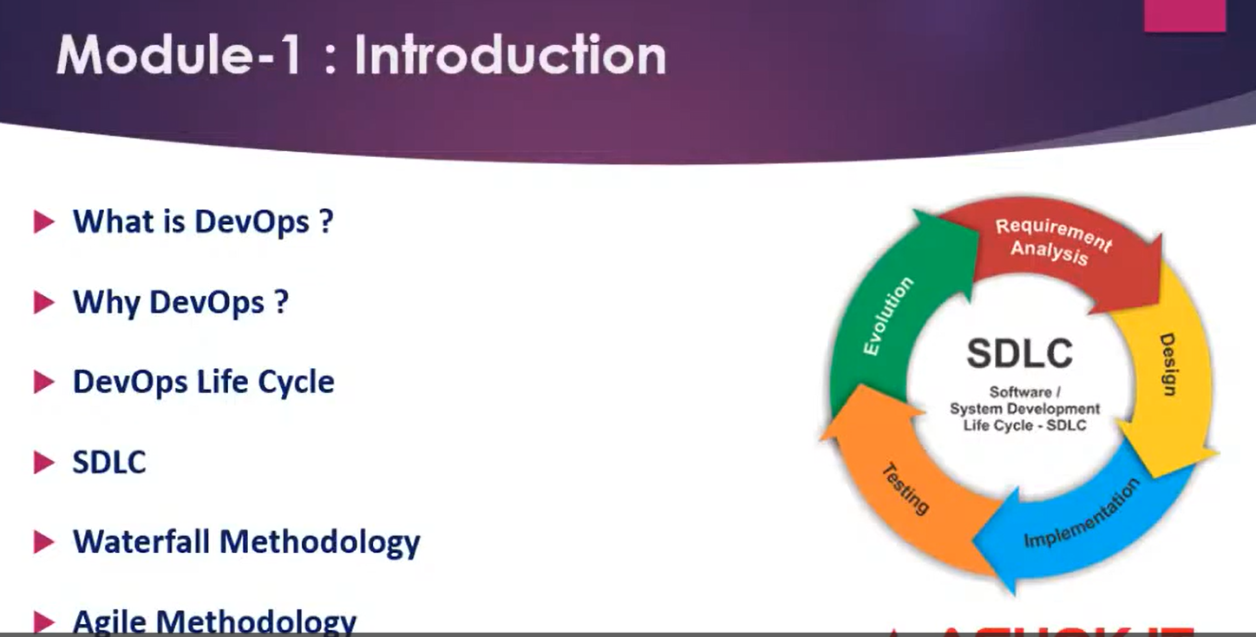

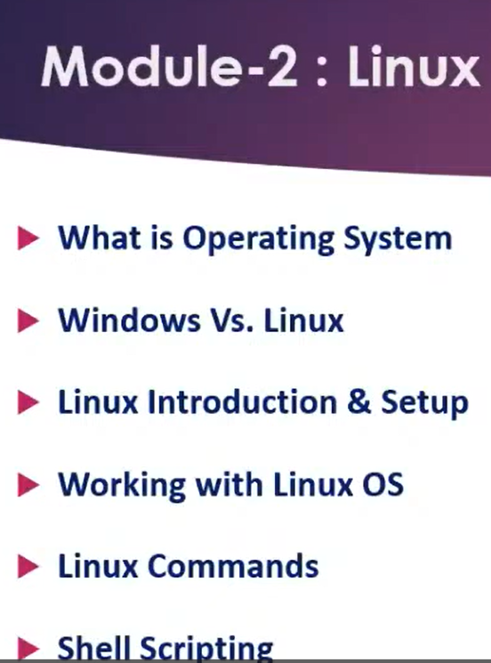

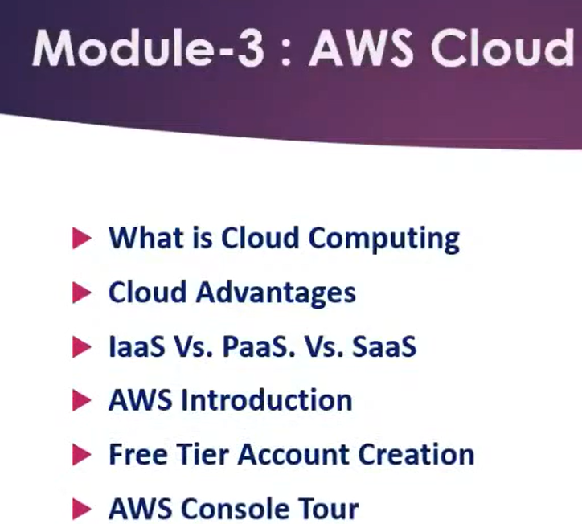

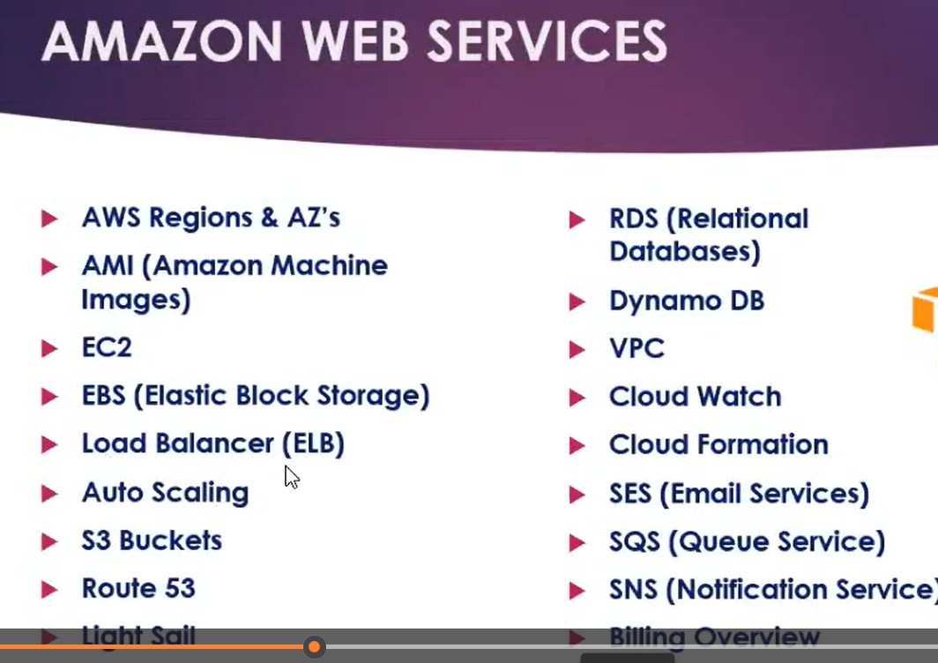

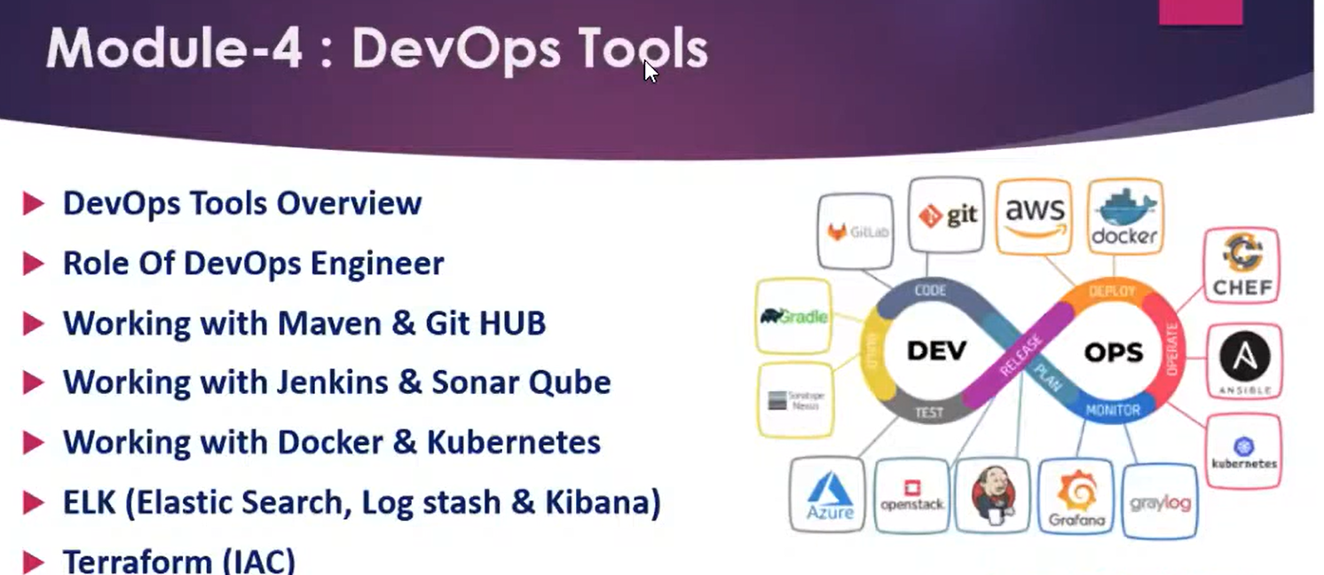

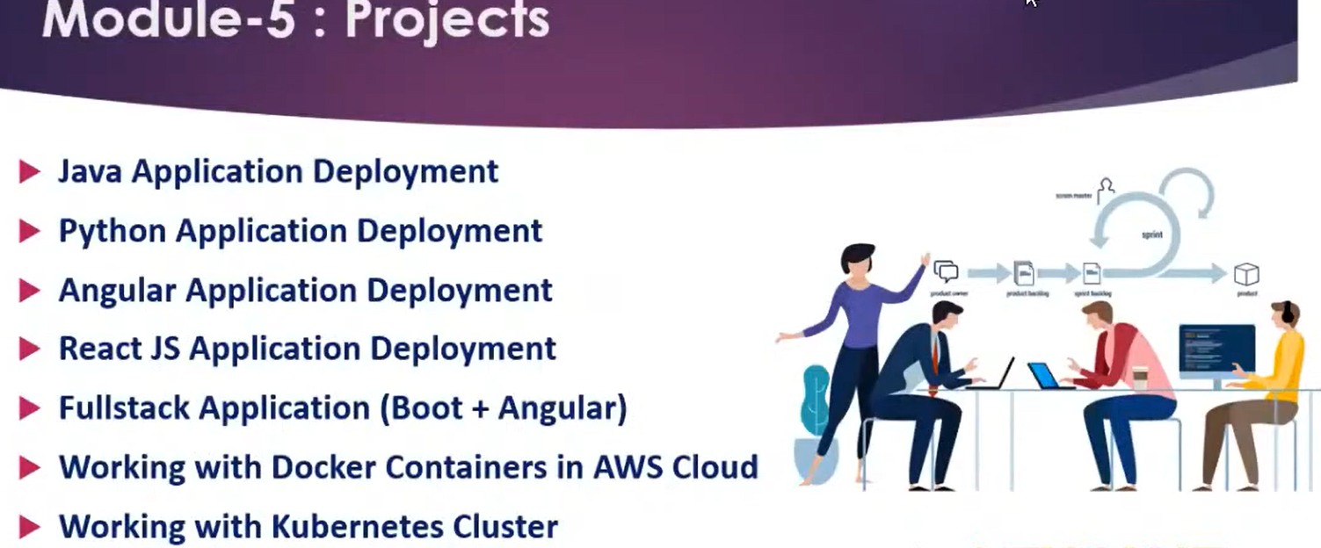

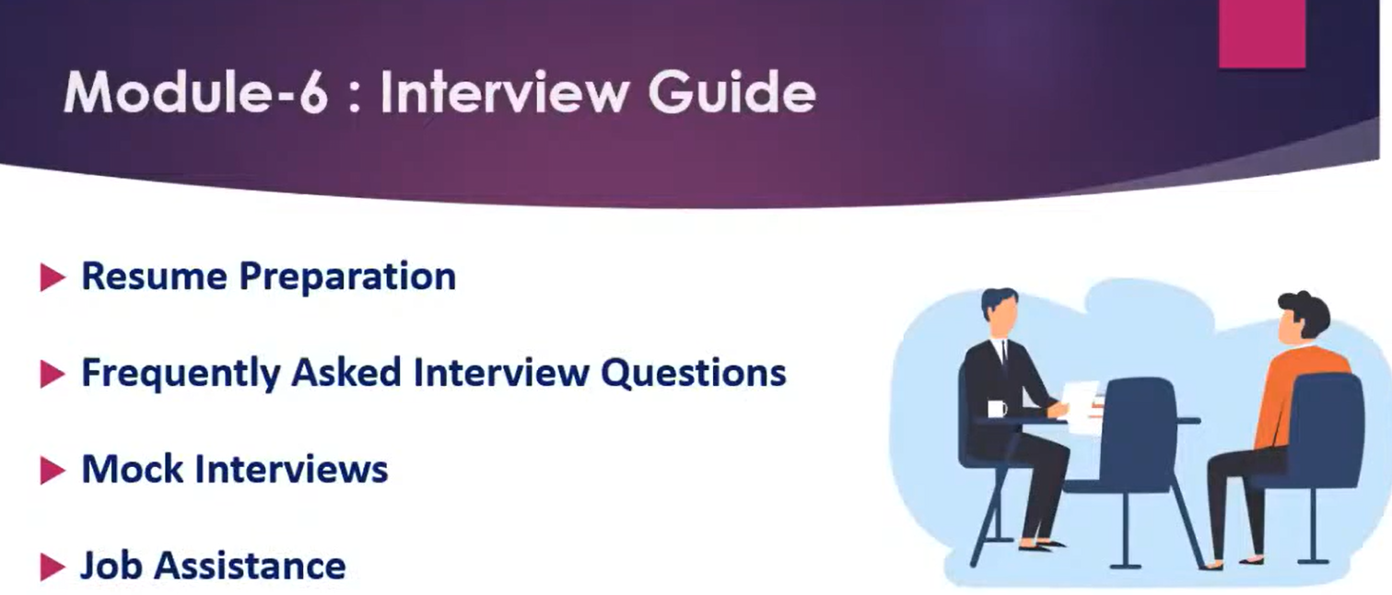

Syllabus

--------

Introduction DevOps world

SDLC (waterfall, Agile)

Introduction to Cloud Computing

Linux OS

Linux Commands

Shell Scripting

AWS Cloud (15+ Services in AWS)

DevTools (10+ Tools)

(Maven, Git Hub, Jenkins, Sonar Qube, Dockers, K8S, Ansible, TerraForm, ELK)

Realtime - Projects (5 different tech stack)

Interview Guide (FAQs, Resume Preparation, Mock Interviews, How to apply for jobs)

-----------------------------------------------------------------------------------------------

Note: After this master program completed you can attend

interviews with 3-4 years exp as DevOps with AWS Engineer

-----------------------------------------------------------------------------------------------

Daily Class Timing : 7:00 PM - 8:00 PM (IST) (Mon-Sat)

Duration : 3 to 3.5 Months

Note: Desktop/Laptop is mandatory to attend this course

-----------------------------------------------------------------------------------------------

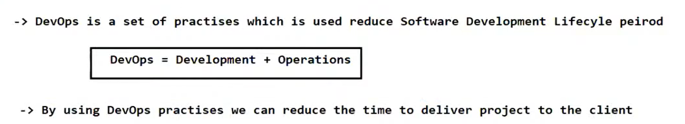

What is DevOps ?

------------------------

-> DevOps is a culture which is used to deliver the projects to the client quickly

-> DevOps means set of practises

-> Using DevOps we can reduce the time of Software Development Life Cycle

-> DevOps means the colloboration between Devlopment and Operations

DevOps = Developmet + Operations

-> Development team is responsible to write the code as per client requirements

-> Once development is completed then Operations team is responsible to deploy and deliver that project to the client

-> By Using DevOps process Development team & Operations team will work together to make sure project is getting delivered to client with in given estimated time.

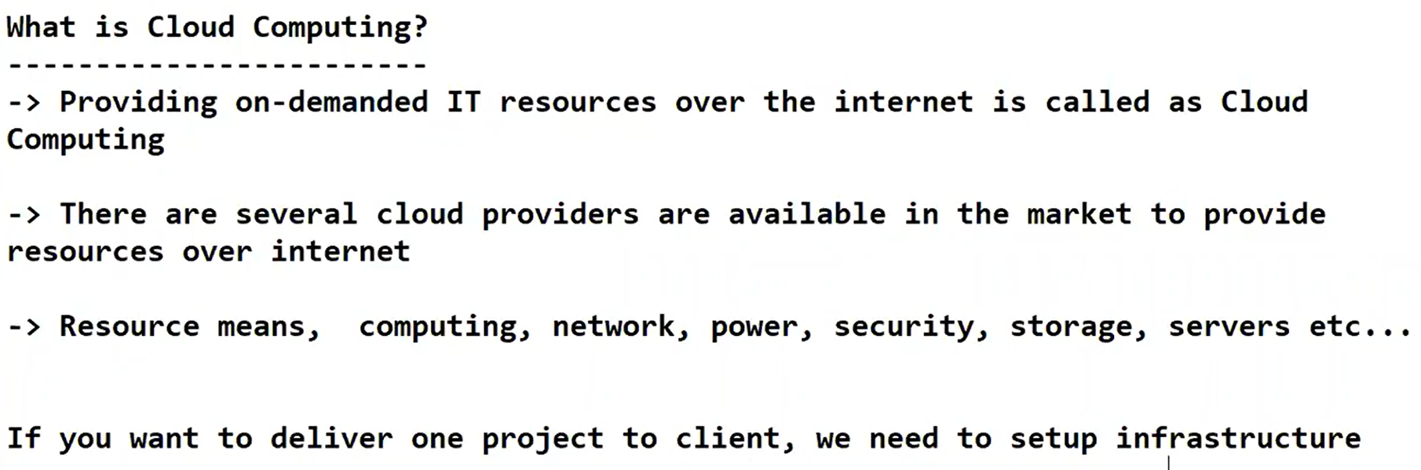

What is Cloud Computing?

*************************

-> Providing on-demanded IT resources over the internet is called as Cloud Computing.

-> There are several cloud providers are available in the market to provide resources over internet

(AWS, Azure, GCP, Salesforce)

-> IT Resource means, computing, network, power, security, storage, servers etc...

If you want to deliver one project to client, we need to setup infrastructure

+++++++++++++++++++++++++++++++++++++++++++++++++++++++++++++++++++++++++++++

1) Purchase computers

2) Purchase Servers to run our application

3) Setup a room to run our servers (Server Room)

4) Setup network for our computers

5) Setup Power Connection For Computers

6) Setup power backup to run our computers 24*7

7) Setup AC for server room

8) Purchase Database Server for our application

9) Recruite Administrators to configure everything requird for application run

10) Take security guard to protect our server room

-> Setting up 'application infrastructure' is costly operation and it is time taking process.

-> Instead of we are purchasing and setting up infrastructure we can take the help of Cloud Providers.

-> Cloud Providers are available in the market to provide infrastructure for rent on 'Pay As You Go' Model.

(Note: Use services and pay the money for usage)

Ex: Credit cards, post paid bills etc...

Example : When we have function in our house we are not going to purchase chairs and tables. We will take them for rent and will use for our function. After the function we will return that material to the owner and will pay rent amount for usage.

-> Similary whatever the infrastructure (machines, servers, network, power, storage) required for our application we can take for rent instead of purchasing.

-> How much we use that much we need to pay for them (Pay As You Go Model)

-> AWS is one of the famous cloud provider available in the market which will provide IT infrastructure for Rent.

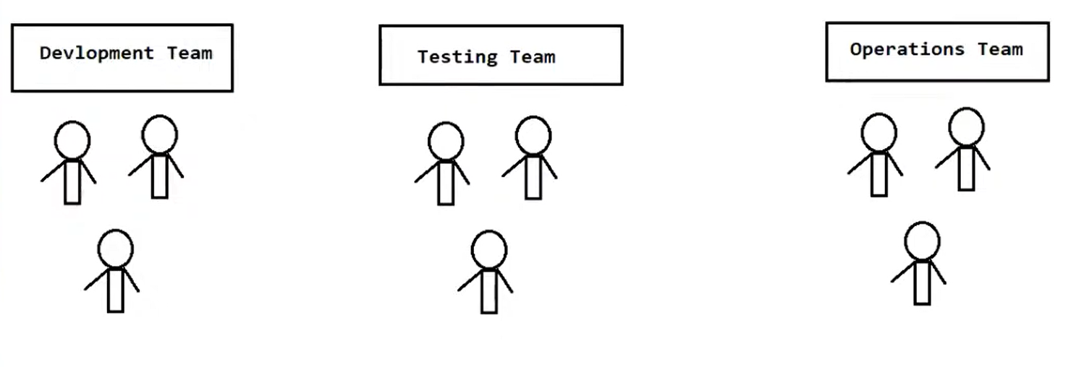

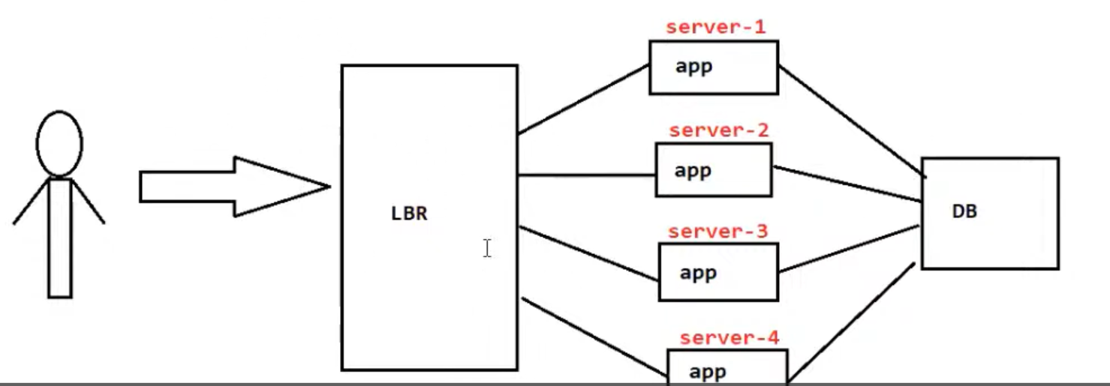

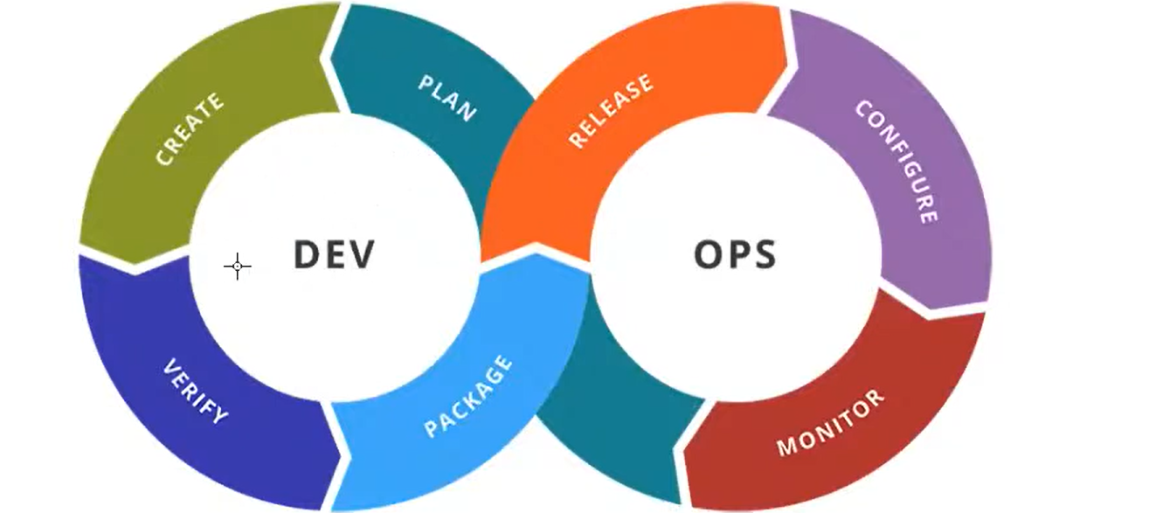

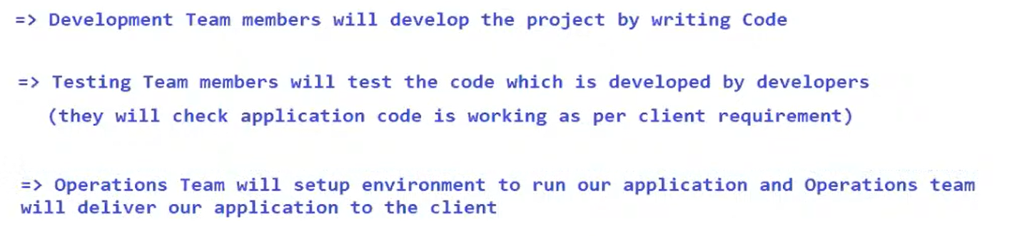

-> Functional team is responsible to collect requirements from the client

-> Development team is responsible to write the code for client given requirements. Developers will develop the project by using programming language.

-> Testing team is responsible to test the code which is done by developers. Testers will verify application functionality is working as per client expectation or not.

-> Operations team is responsible to build, deploy and deliver project to client

Note: After learning DevOps with AWS you will become Application Operations Engineer

-> DevOps engineer is called as Operations Engineer

-> As a DevOps engineer you will perform Operations Required For the Application.

-> DevOps team is also called as Release Team.

-> Release Team is responsible to release project to the client (Deploy & Deliver)

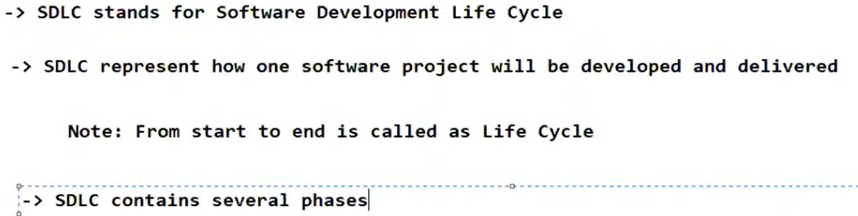

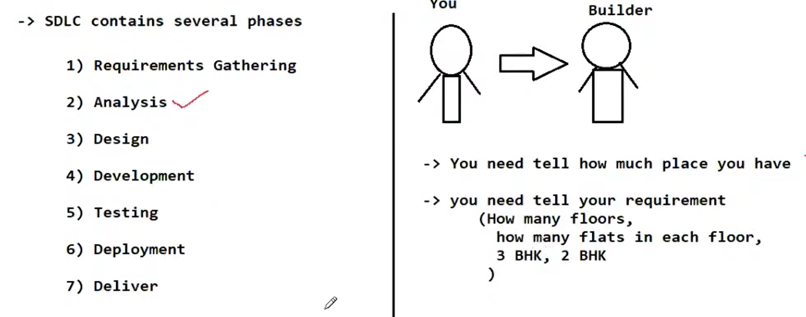

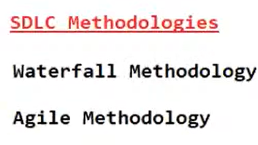

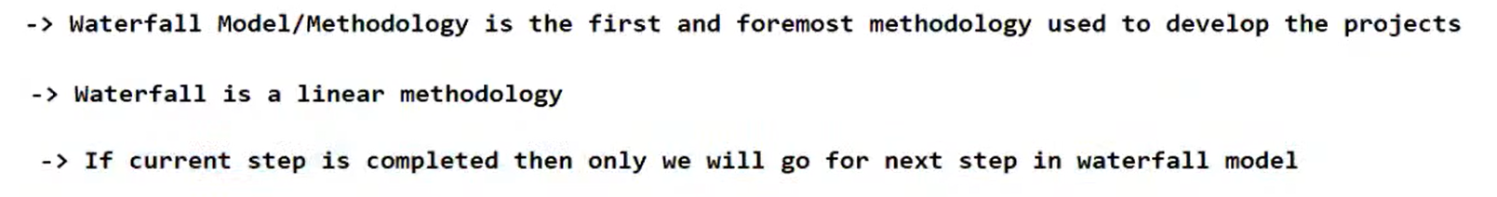

\

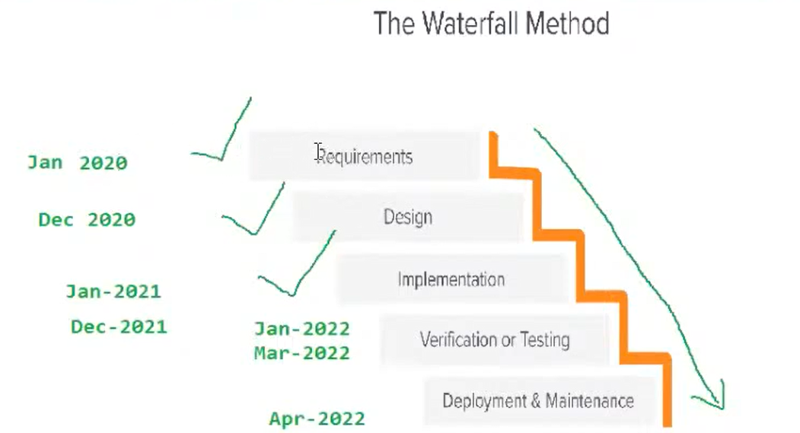

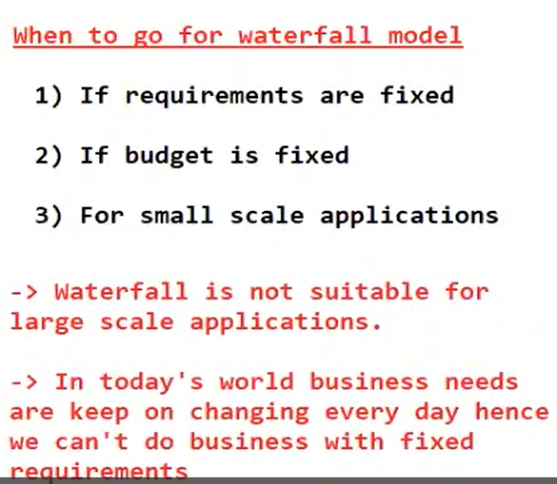

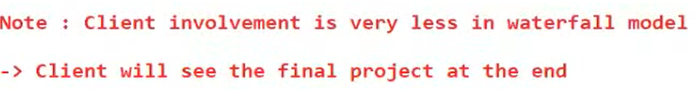



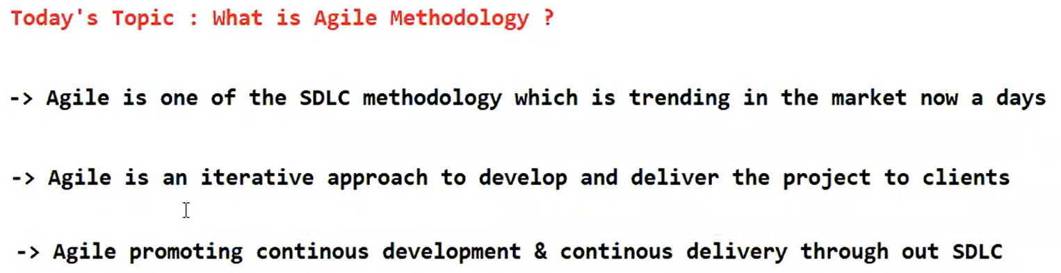



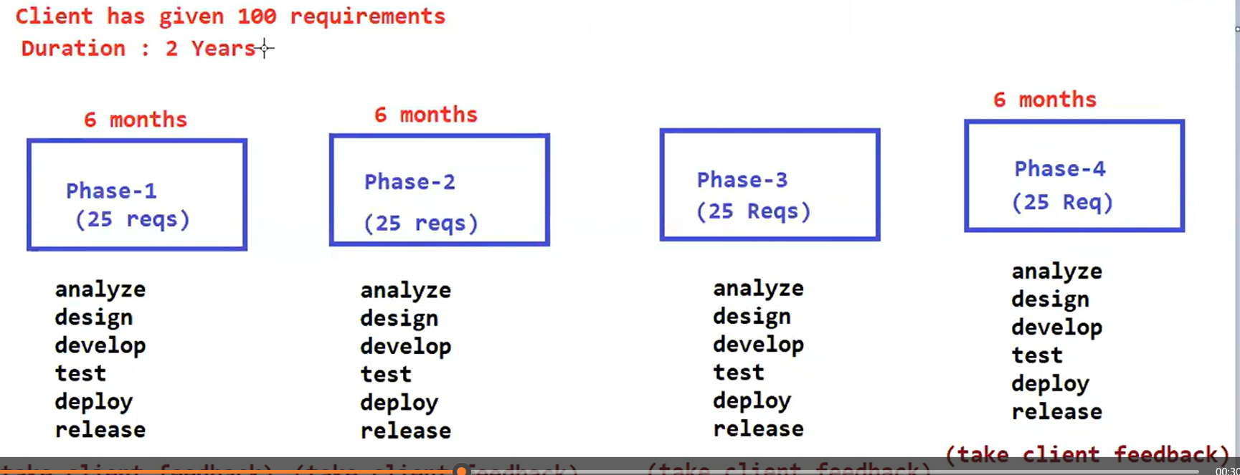

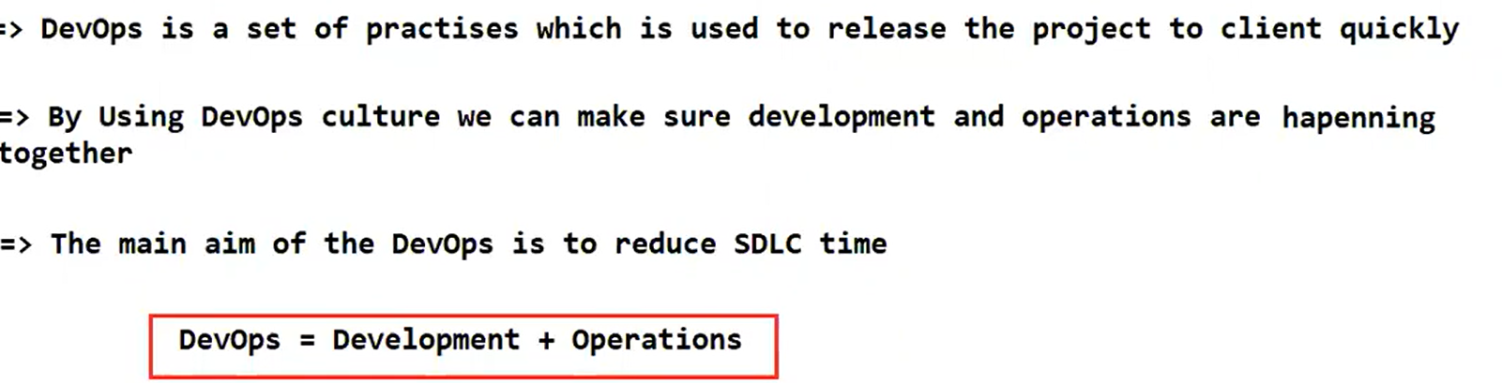

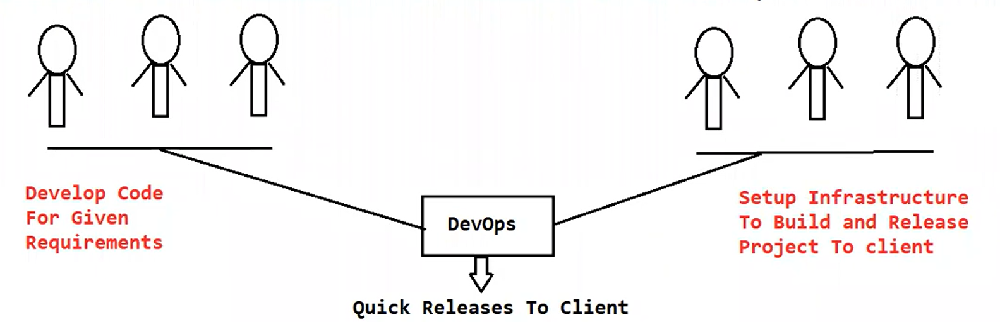

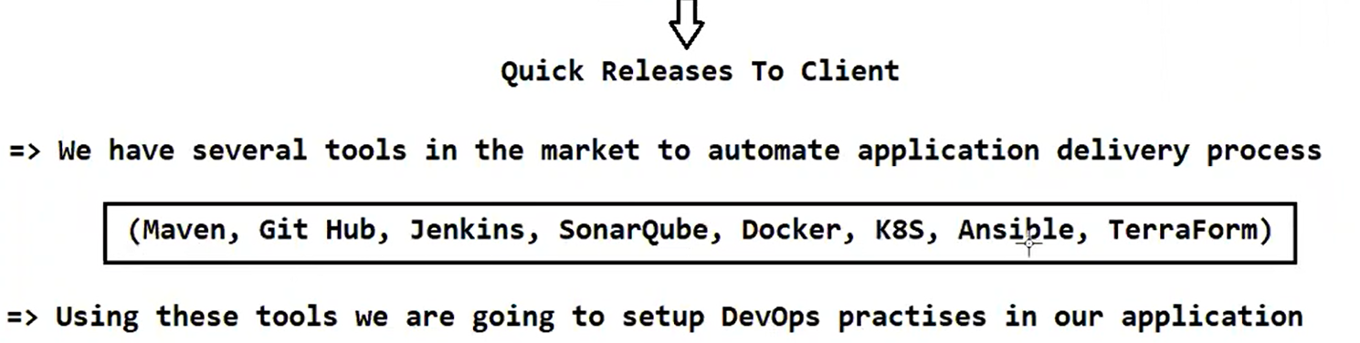

Roles & Responsibilities of DevOps Engineer

-------------------------------------------

1) Setup Infrastructure Required To Run our application

(setup servers, database, LBR etc)

2) Take the code which is done by developers from "Source Code Repository"

(SVN or Git Hub or BitBucket)

3) Build the code using Build Tools

(Maven, Gradle)

4) Deploy the code into servers using CI CD tools

(Jenkins, UDeploy etc)

5) Deliver Project to the client

Note: Now a days companies are preffering cloud infrastructure to reduce cost and maintenence.

-> Being DevOps engineer you should know Cloud Platforms also.

Application Architecture

------------------------

-> Every web application comes under Client-Server Architecture

-> Server is a container which is going to run our web application

Ex : Apache Tomcat, Weblogic, Websphere, Glassfish, IIS etc..

-> Client means the user who is accessing web application running in the server. Clients will use Browser to access the application running the server.

request

Client <------------------------------> Server

Response

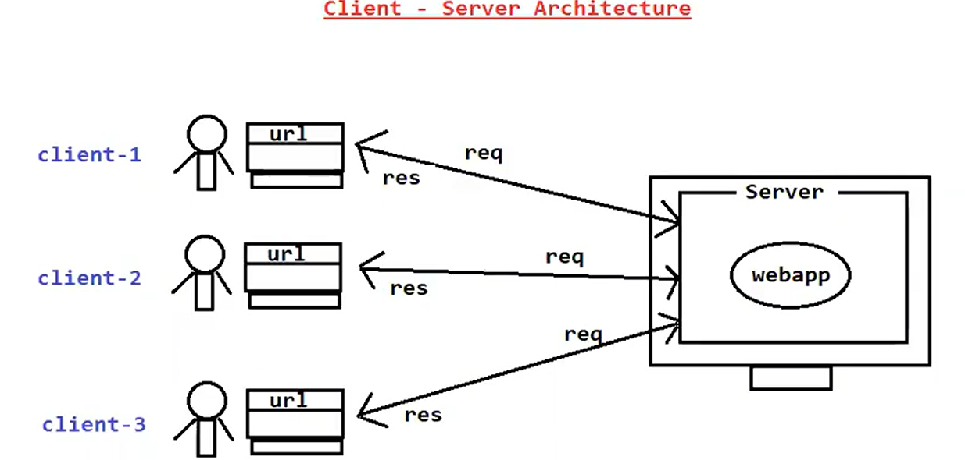

-> Multiple clients can access web application at a time

Ex: We all are using facebook, gmail, irctc, ashokit etc..

-> If multiple users access the application then burden will be increased on the server.

-> To reduce burden on the server we will use Load Balancing in the Realtime.

++++++++++++++++++++++++++++++++++++++++++++++++++++++++++++++++++++++

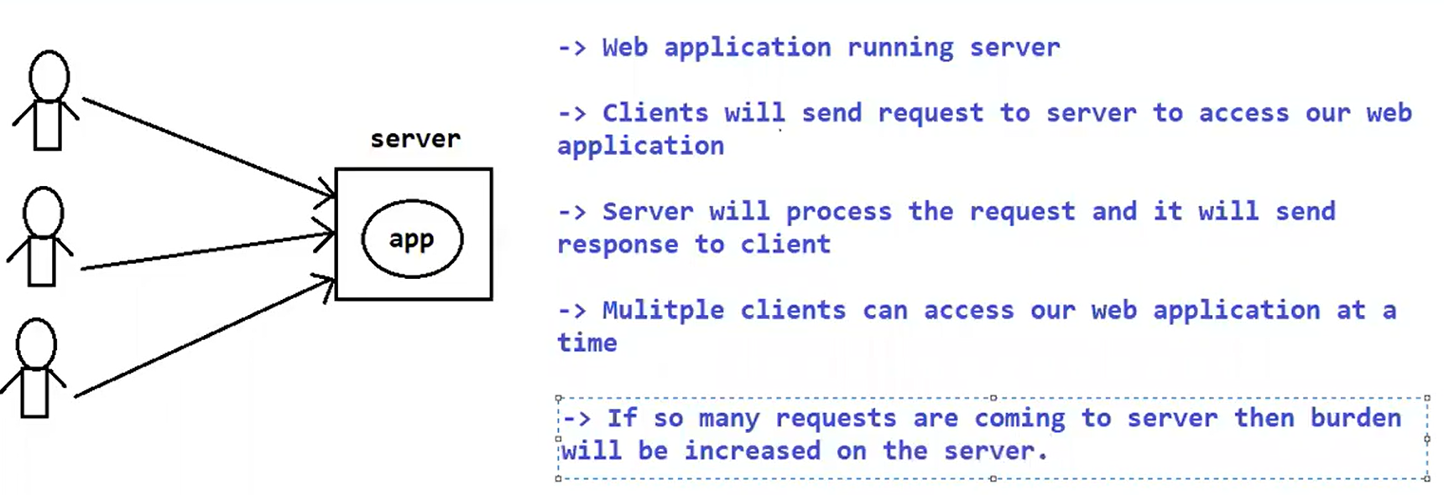

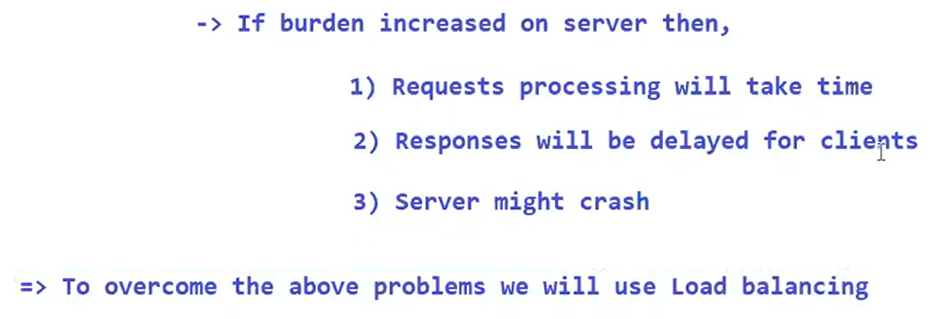

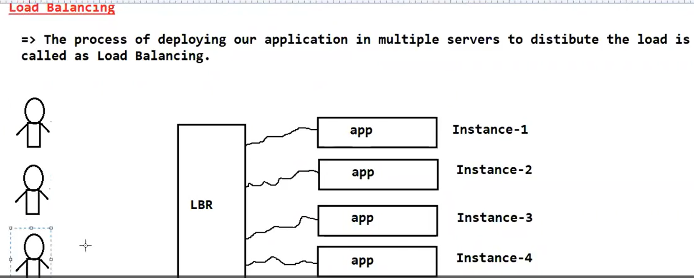

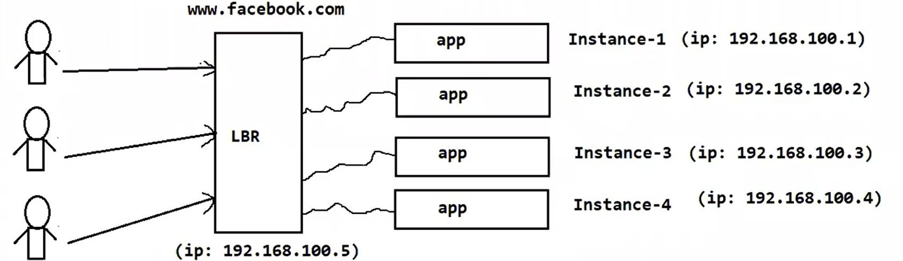



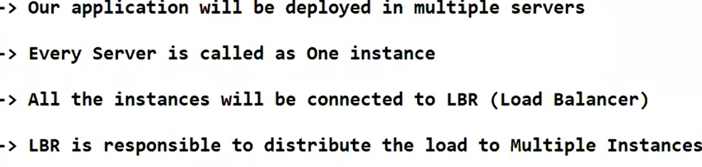

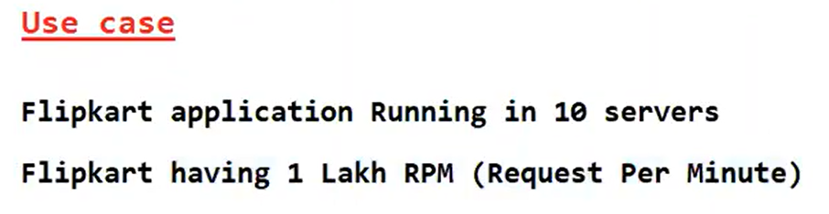

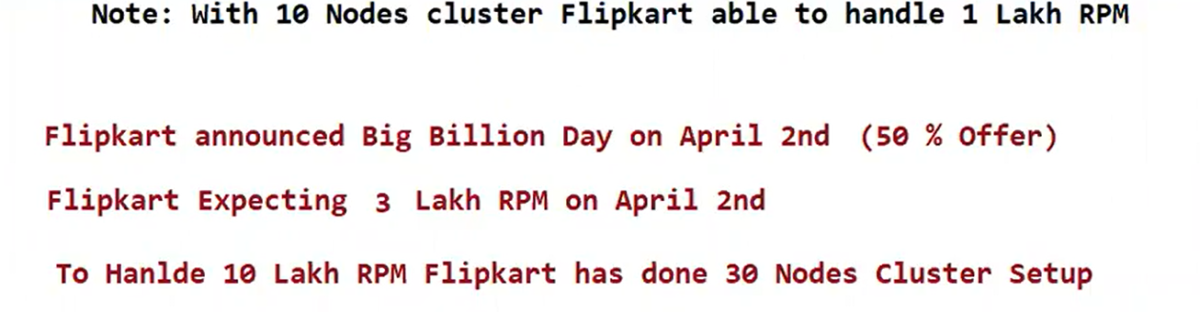

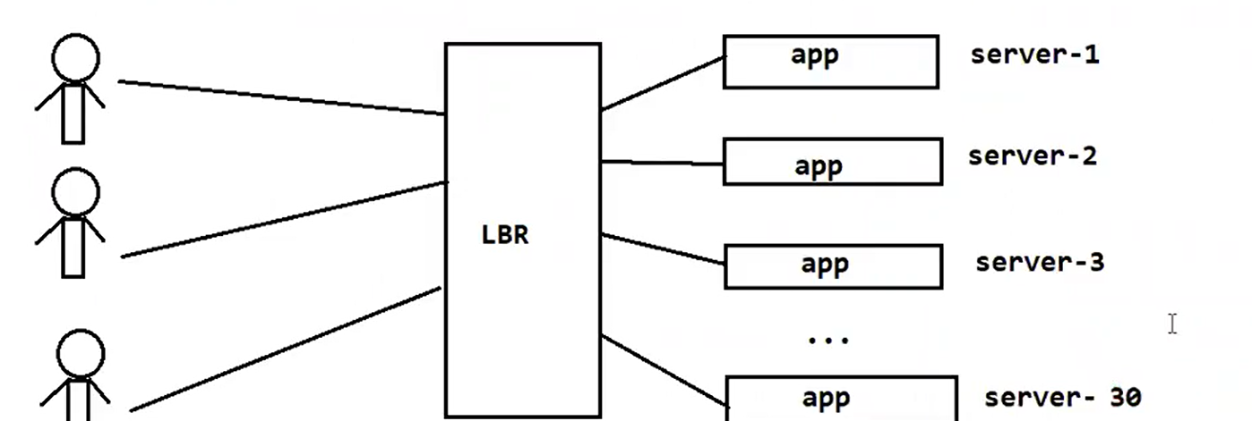

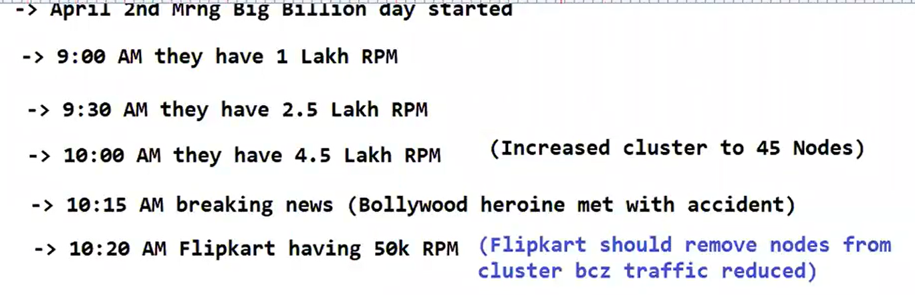

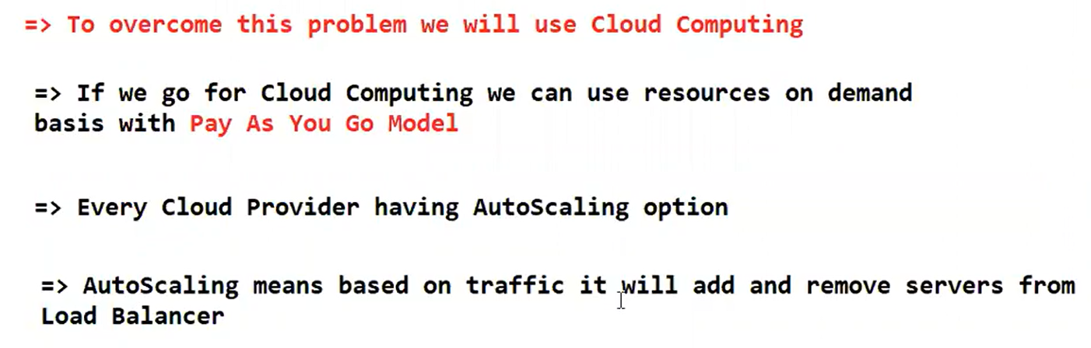

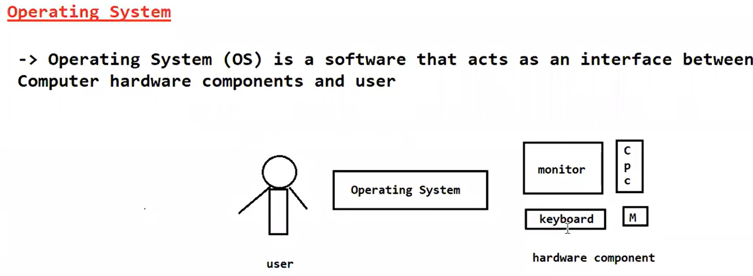

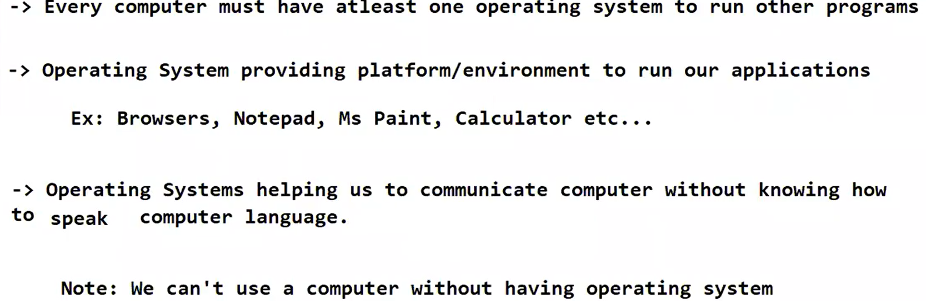

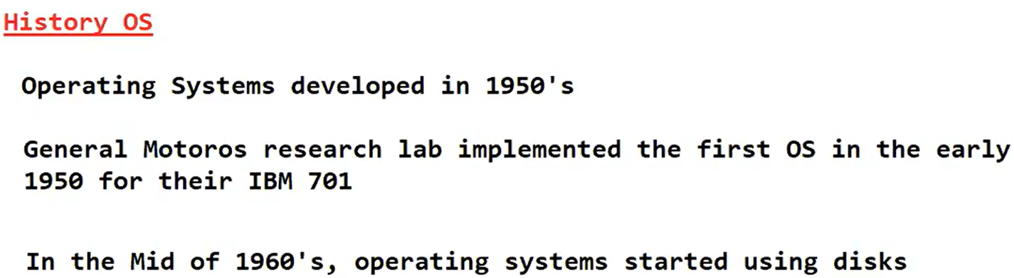

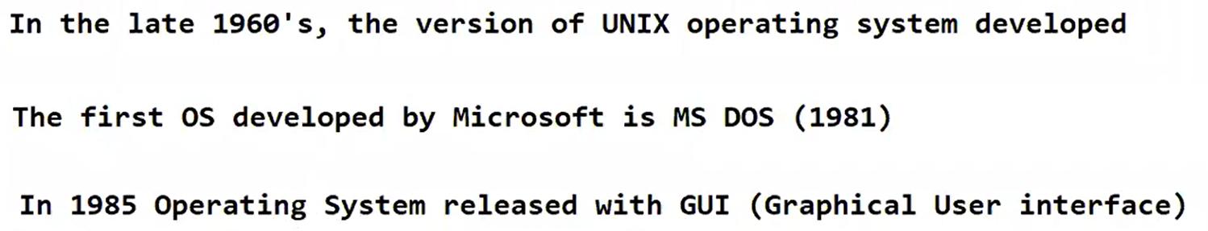

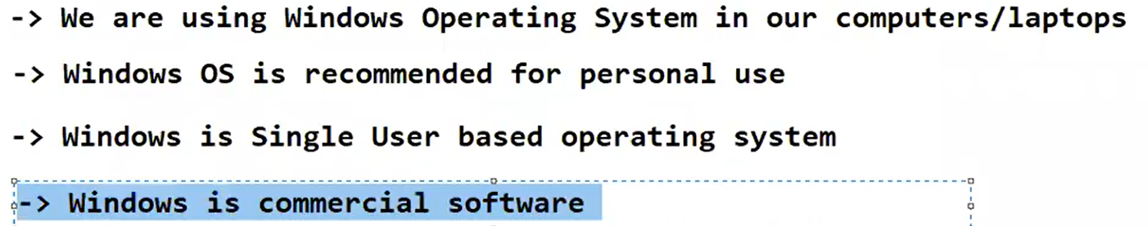

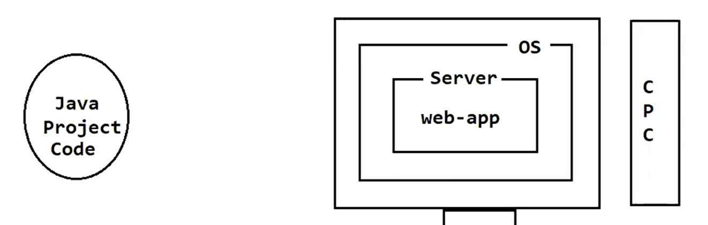

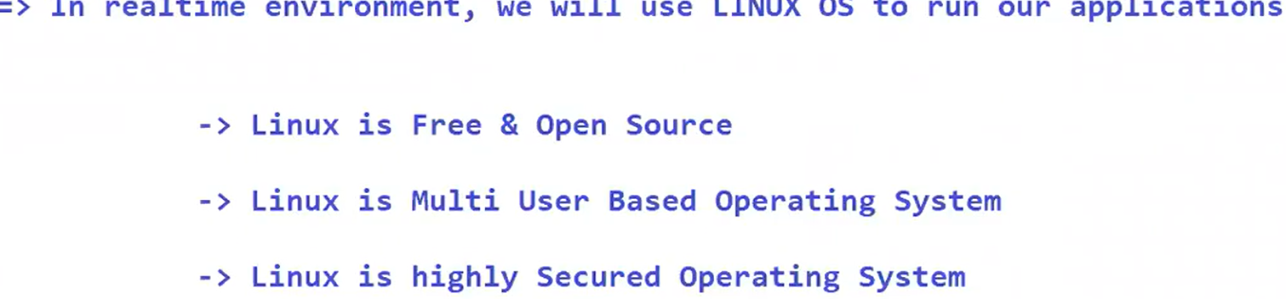

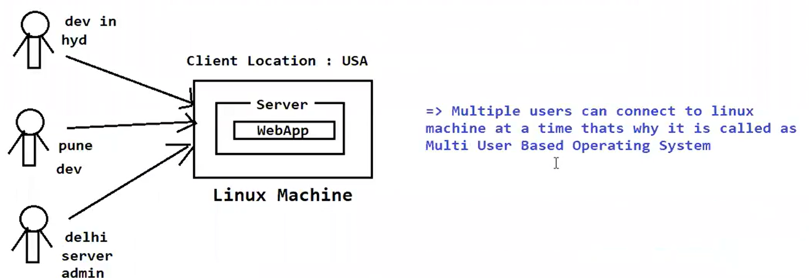

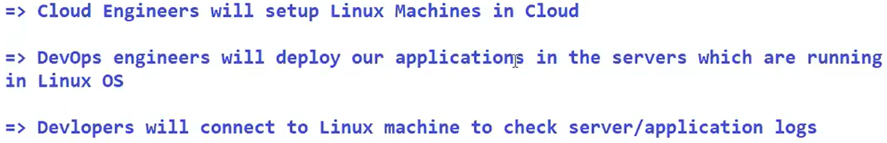

Yesterday's session : What is Operating System ?

------------------------------------------------

-> Operating System is acting as mediator between users and computer hardware components

-> Operating System is mandatory to use any computer

-> OS provides environment to run other applications

(browser, notepad, paint, calc)

-> The OS came into market in 1950

-> Microsoft released it's first OS in 1981 (MS DOS)

Windows OS

----------

-> Developed by Microsoft

-> It is having GUI

-> It is single user based Operating System

-> It is commercial (paid)

-> Less Security

-> It is recommended for personal use

Linux OS

--------

-> Linux is Community Based OS

-> Linux is Free & Open Source

-> Linux is Multi User Based OS

-> High Security

-> Recommended to use for Applications, Servers, Databases etc..

Note: In realtime, we will use Linux OS only to setup infrastructure required to run our application

-> Linux OS is not only for Administrators, even developers and testers also will use Linux OS in realtime to monitor our application and application servers.

History Of Linux

-----------------

-> In 1991, a student 'Linus Torvalds' developed this Linux OS

-> Linux Torvalds identified some challenges in UNIX OS and he suggested some changes

for Unix OS but UNIX OS Team rejected 'Linux Torvalds 'suggestions

-> Linus Torvalds used Minux OS to develop Linux

Linus + Minux

-> First Two letters from his name and last 3 letters from Minux OS

LI + NUX => LINUX

-> Linus Torvalds released LINUX OS with source code into market so that anybody can modify LINUX OS thatys why it is called as Open Source Operating System.

-> As Linux OS is open source, so many people and companies taken that Linux OS and modified according to their requirement and released into market with different names those are called as Linux Distributions.

RHEL -- RED HAT

Ubuntu OS

Cent OS

Fedora

Open SUSE

Kali Linux

Debian

Note : 200+ Linux Distributions are available in the market.

Environment Setup

-----------------

=> We can setup Linux Machine in 2 ways

1) By using Hypervisor with Virtual Box

2) Cloud VM-> Documents shared to create AWS account & Linux VM Launching in AWS (Follow the given docs and complete the assignment)

---------------------------------------------------------------------------------------------

1) Create account in AWS (it will ask debit/credit card) - selected cards are accepted

2) Create Linux VM using AWS EC2 service (download key pair)

3) Convert .pem to .ppk using puttygen software

4) Open putty S/w and connect to EC2 VM using IP & PPK file

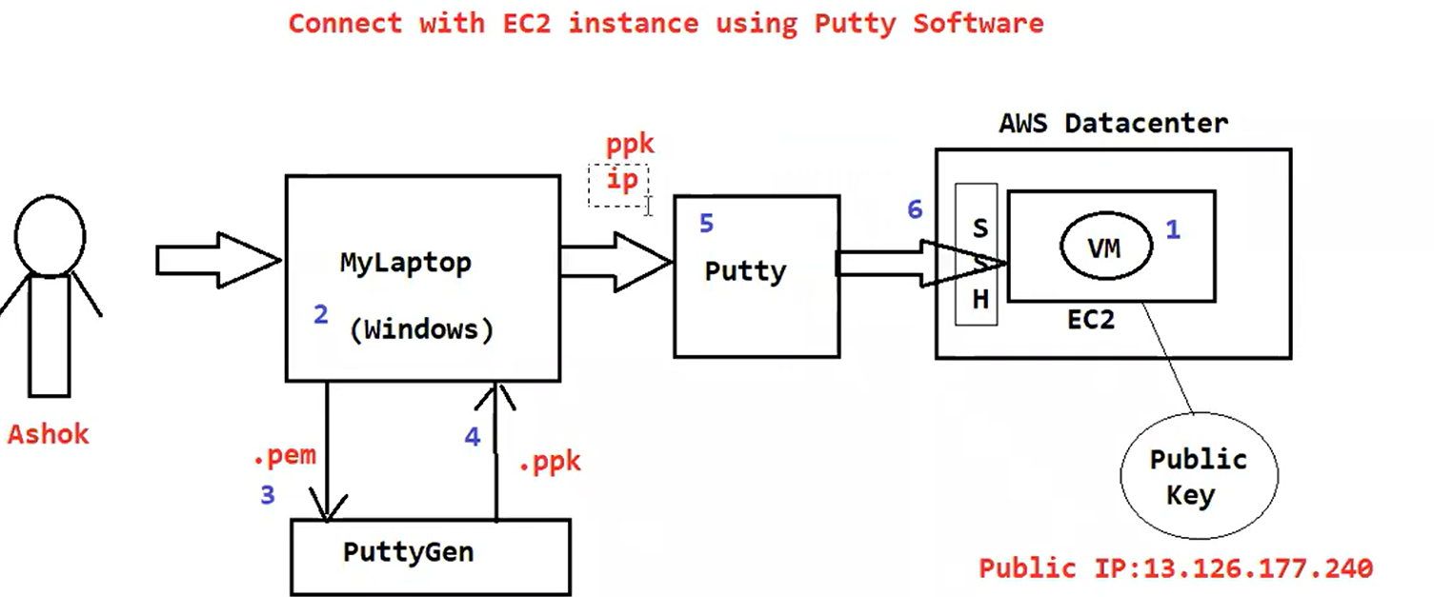

---------------------------------------------------------------------------------------------

Linux VM is ready. It is up and running in AWS Cloud

We are able to connect with Linux VM using Putty S/w

-----------------------------------------------------------------------------------------------

Linux Commands

----------------------------------------------------------------------------------------------

whoami : It will display currently logged in username

pwd : present working directory

date : To display current date

cal : To display calendar

-> In Linux everything everything will be represented as file

-> We have 3 types of files in linux

1) Ordinary File / Normal File (it will start with -)

2) Directory File (it will start with d)

3) Link File (it will start with l)

-> The file which contains data is called as ordinary file

-> Directory file is equal to folder (it can contain files and folders)

-> The file which is having linking is called as Link File

=> touch : it is used to create empty file

$ touch f1.txt

$ touch f2.txt

$ touch f3.txt f4.txt

=> To display files we will use 'ls' command

$ ls

=> To create a file with data we will use 'cat' command

$ cat > hello.txt

//write data

press CTRL + d (to save and exit)

$ cat hello.txt (To display file data)

$ cat >> hello.txt (To append data in the file)

//write data

press CTRL + d (to save and exit)

-> To create directory we will use 'mkdir' command

$ mkdir dirname

-> To remove the file we will use 'rm' command

$ rm filename

-> To remove empty directory we will use 'rmdir' command

$ rmdir dirname

===============================================================================================

1 clear

2 whoami

3 pwd

4 date

5 cal

6 clear

7 touch f1.txt

8 ls

9 touch f2.txt

10 ls

11 touch f3.txt f4.txt

12 ls

13 cat > hello.txt

14 ls

15 cat hello.txt

16 cat > hello.txt

17 cat hello.txt

18 cat >> hello.txt

19 cat hello.txt

20 clear

21 ls

22 touch f5.txt

23 ls

24 cat > f6.txt

25 cat f6.txt

26 cat >> f6.txt

27 cat f6.txt

28 clear

29 mkdir movies

30 ls

31 cat f1.txt

32 cat > f1.txt

33 cat f1.txt

34 rm f2.txt

35 ls

36 rmdir movies

37 ls

38 history

-----------------------------------------------------------------------------------------------

=> 'ls' is used to list out all files & directories available in the given directory

Note: we can pass several options for 'ls' commands

-> ls : It will display all files in alphabetical order (a to z)

-> ls -r : It will display all files in reverse of alphabetical order (z to a)

-> ls -l : It will display long listing of files

-> ls -t : It will display all files based on last modified date and time. Most recent file will be display at top and old files will display at bottom.

-> ls -rt : It will display all files based on reverse of last modified date and time. Old files will display at top and recent files will display bottom.

-> ls -a : It will display all files including hidden files (hidden files will start with .)

-> ls -li : It will display files with inode.

-> ls -lR : It will display all files and directories along with sub directoris content

Note: -R represents recursive

Note: We can use several options for ls command at a time. When we are using multiple options order of the options is not important

$ ls -ltr

$ ls -tlr

$ ls -l -t -r

$ ls -trl

Note: All the above commands will give same output

-> To display content of given directory we can execute like below

$ ls <dirname>

-> To delete a file we will use 'rm' command

$ rm <filename>

-> To delete empty directory we will use 'rmdir' command

$ rmdir dirname

-> To delete non-empty directory we will use 'rm' command like below

$ rm -r dirname

-> To display file content we will use 'cat' command

$ cat filename

-> To display file content with line numbers we will use '-n' option

$ cat -n filename

-> To display multiple files content at a time execute command like below

$ cat file1 file2 file3

-> Copy one file data into another file using 'cat' command

$ cat f1.txt > f8.txt

-> Copy more than one file data into another file

$ cat f1.txt f2.txt > f9.txt

Reversing File Content

----------------------

-> 'tac' command is used to reverse file content

$ tac filename

-> 'rev' command is used to reverse each line content of the file

$ rev filename

head command

-------------

-> head command is used to display file data from top (default 10 lines)

$ head filename

$ head -n 5 data.log (first 5 lines data)

~$ head -n 20 data.log (first 20 lines data)

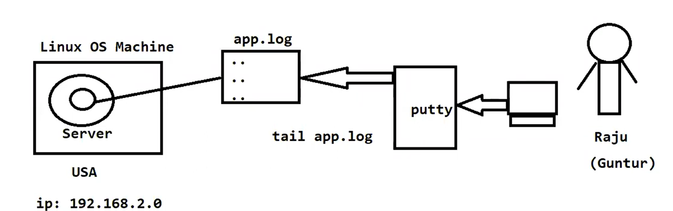

tail command

-------------

-> tail command is used to display file data from bottom (default 10 lines)

$ tail filename (last 10 lines data)

$ tail -n 100 filename (last 100 lines data)

$ tail +25 filename (it will display data from 25th line to bottom)

Note: To see on-growing logs we can use '-f' option

$ tail -f data.log (Live log message we can see)

wc command

-----------

-> It is used to count no.of lines, no.of words and no.of characters in the file

ubuntu@ip-172-31-47-242:~$ wc f1.txt

2 8 45 f1.txt

ubuntu@ip-172-31-47-242:~$

---------------------------------------------------------------------------------------------

1 clear

2 whoami

3 pwd

4 date

5 cal

6 clear

7 touch f1.txt

8 ls

9 touch f2.txt

10 ls

11 touch f3.txt f4.txt

12 ls

13 cat > hello.txt

14 ls

15 cat hello.txt

16 cat > hello.txt

17 cat hello.txt

18 cat >> hello.txt

19 cat hello.txt

20 clear

21 ls

22 touch f5.txt

23 ls

24 cat > f6.txt

25 cat f6.txt

26 cat >> f6.txt

27 cat f6.txt

28 clear

29 mkdir movies

30 ls

31 cat f1.txt

32 cat > f1.txt

33 cat f1.txt

34 rm f2.txt

35 ls

36 rmdir movies

37 ls

38 history

39 cls

40 clear

41 whoami

42 pwd

43 date

44 cal

45 clear

46 ls

47 touch f7.txt

48 cat > f8.txt

49 cat f8.txt

50 cat >> f8.txt

51 cat f8.txt

52 mkdir test

53 ls

54 rm f8.txt

55 rmdir test

56 clear

57 ls

58 ls -r

59 ls -l

60 ls -t

61 ls -lt

62 cat > one.txt

63 clear

64 ls -l

65 ls -r

66 ls -lr

67 ls -t

68 ls -lt

69 clear

70 ls -rt

71 ls -ltr

72 ls -trl

73 mkdir aws

74 mkdir devops

75 mkdir linux

76 clear

77 ls -lt

78 ls -a

79 ls -la

80 ls -

81 ls -l

82 ls -la

83 ls -F

84 ls -lF

85 ls -li

86 clear

87 ls -l

88 pwd

89 cd aws

90 pwd

91 touch ec2.txt s3.txt rds.txt

92 ls -l

93 cd ..

94 pwd

95 clear

96 ls -l

97 ls -R

98 ls -lR

99 clear

100 ls -l

101 ls -lR

102 clear

103 ls -l

104 ls linux

105 ls aws

106 ls devops

107 ls aws

108 ls linux

109 rmdir linux

110 ls -l

111 rmdir devops

112 ls aws

113 rmdir aws

114 clear

115 rm -r aws

116 ls -l

117 clear

118 cat f1.txt

119 cat >> f1.txt

120 cat f1.txt

121 cat f2.txt

122 cat > f2.txt

123 cat f2.txt

124 cat -n f1.txt

125 cat f1.txt f2.txt

126 clear

127 ls -l

128 cat f1.txt

129 cat f1.txt > f8.txt

130 ls -l

131 cat f8.txt

132 cat f1.txt

133 cat f2.txt

134 clear

135 ls -l

136 cat f1.txt f2.txt > f9.txt

137 cat f9.txt

138 clear

139 cat f1.txt

140 tac f1.txt

141 rev f1.txt

142 clear

143 cat > data.lgo

144 clear

145 cat data.lgo

146 clear

147 cat > data.log

148 cat data.log

149 clear

150 head data.log

151 head -n 5 data.log

152 clear

153 head -n 20 data.log

154 clear

155 head -q data.log

156 clear

157 tail data.log

158 tail -n 100 data.lgog

159 tail -n 100 data.log

160 tail -n 200 data.log

161 clear

162 tail +25 data.log

163 clear

164 tail -f data.log

165 clear

166 wc f1.txt

167 clear

168 history

----------------------------------------------------------------------------------

-> When application running, it will generate log messages and it will store log messages at bottom of the file.

-> To see log messages of the application we will use 'tail' command

cp command

---------

-> To copy the data from one file to another file

$ cp one.txt two.txt ( or ) $ cat one.txt > two.txt

$ cp f1.txt f2.txt f3.txt (invalid syntax)

-> We can't copy morethan one file data using 'cp' command. To copy multiple files data we should go for 'cat' command

$ cat f1.txt f2.txt > f3.txt

Rename the files or directories

--------------------------------

-> To rename files we will use 'mv' command

$ mv f1.txt f1111.txt

$ mv dirname dirnewname

Note: We can use 'mv' command for renaming and moving files

Comparing files

---------------

-> To compare files we can use below commands

$ cmp f1.txt f2.txt

$ diff f1.txt f2.txt

-> cmp command will display only first difference in given 2 two files

-> diff command will display all the differences in the content



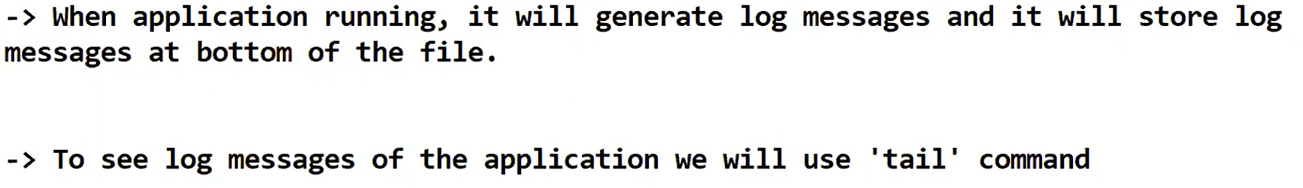

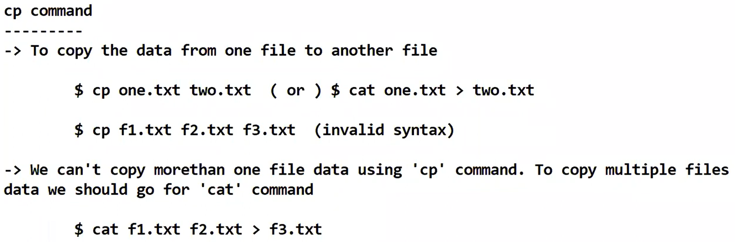

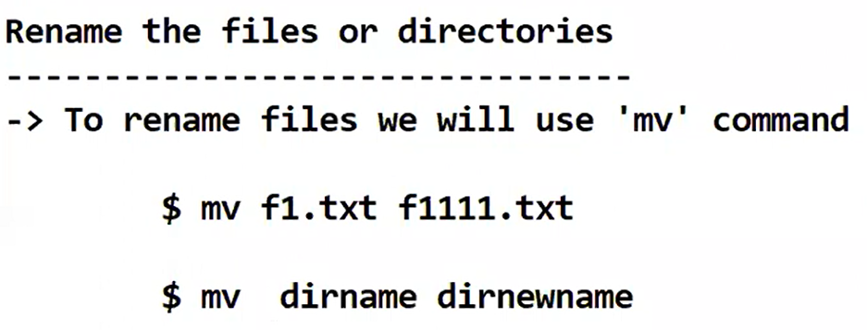

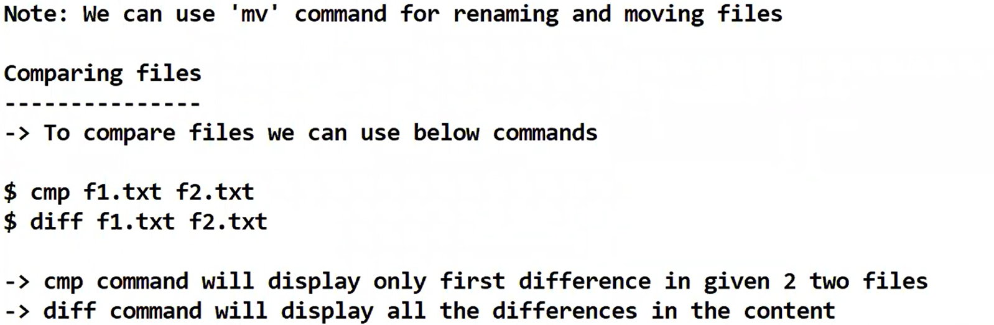

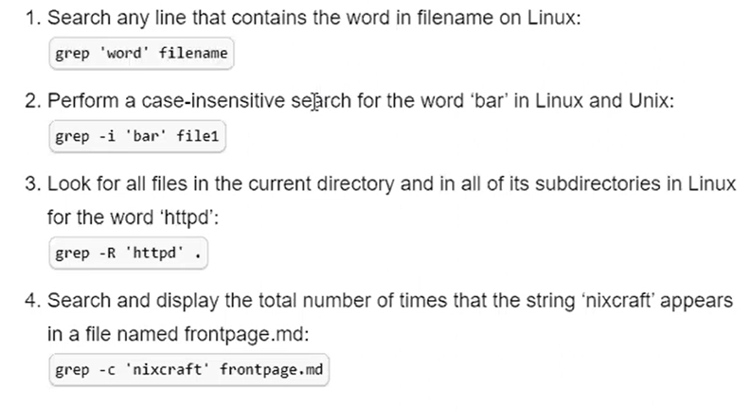

grep command

------------------

-> 'grep' stands for global regular expression print.

-> 'grep' command will process the text line by line and prints any lines which matches given pattern.

Ex: I want to print all lines which contains 'NullPointerException'

$ grep -i 'NullPointerException' *

Note: We can install grep using below command

$ sudo yum install grep

//search for the lines which contains given word in the given filename

$ grep 'word' filename

//search for the lines which are having exception keyword in server.log file

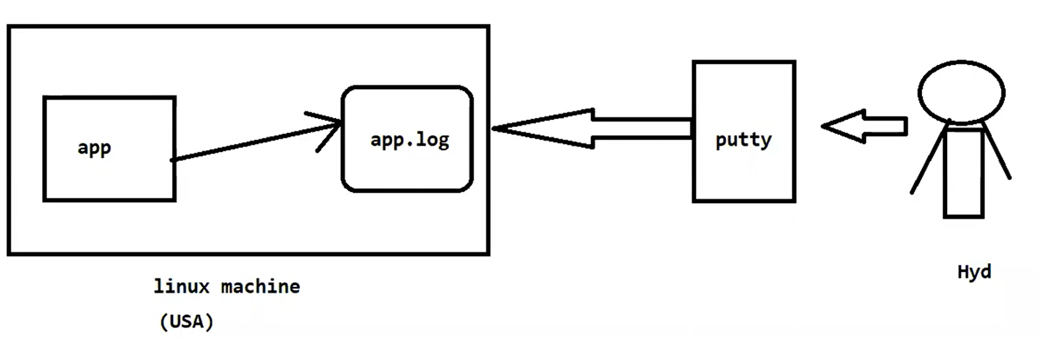

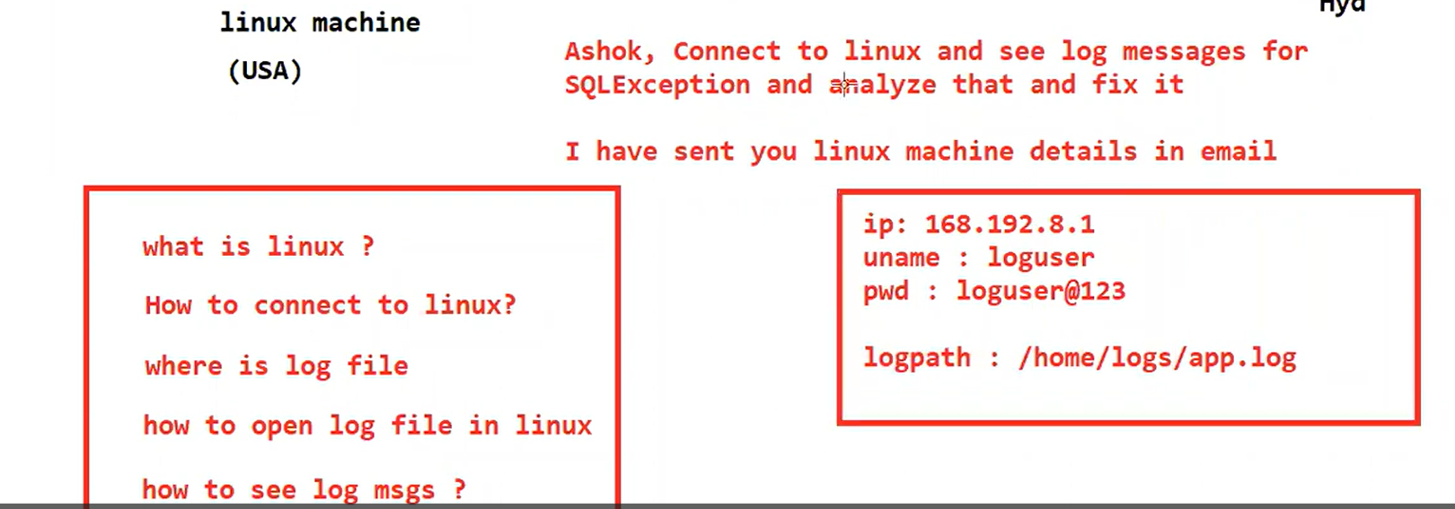

$ grep -i 'exception' server.log

//search for the given text in present directory and in sub-directories also

$ grep -R 'exception'

=> We can pass several options for 'grep' command

-c : This prints only the count of files that matches give pattern

-i : ignore case-sentitivty

-n : Display the matched lines and their line numbers

-l : Displays only file names that matches the pattern

-h : Displays matched lines without file names

-R : Displays matched lines with file names

Working with Text Editors in Linux

==================================

The default editor that comes with the UNIX operating system

is called vi (visual editor).

Using vi editor, we can edit an existing file or create a new file from scratch.

We can also use this editor to just read a text file.

Modes of Operation in vi editor

+++++++++++++++++++++++++++++++++

There are three modes of operation in vi:

1) command mode

2) insert mode

3) escape mode

Command Mode:

---------------

When vi starts up, it is in Command Mode. This mode is where vi interprets any characters we type as commands and thus does not display them in the window

This mode allows us to move through a file, and to delete, copy, or paste a piece of text.

To enter into Command Mode from any other mode, it requires pressing the [Esc] key. If we press [Esc] when we are already in Command Mode, then vi will beep or flash the screen.

Insert mode:

--------------

This mode enables you to insert text into the file.

Everything that’s typed in this mode is interpreted as input and finally, it is put in the file.

The vi always starts in command mode. To enter text, you must be in insert mode.

To come in insert mode you simply type i.

To get out of insert mode, press the Esc key, which will put you back into command mode.

Last Line Mode(Escape Mode):

-----------------------------

Line Mode is invoked by typing a colon [:], while vi is in Command Mode.

The cursor will jump to the last line of the screen and vi will wait for a command.

This mode enables you to perform tasks such as saving files, executing commands.

There are following way you can start using vi editor :

Commands and their Description

---------------------------------

vi filename: Creates a new file if it already not exist, otherwise opens existing file.

vi -R filename : Opens an existing file in read only mode.

view filename : Opens an existing file in read only mode.

vi f1.txt

=> After making changes if we don't want to save those changes then execute :q!

Moving within a File(Navigation):

-----------------------------------

To move around within a file without affecting text must be in command mode (press Esc twice). Here are some of the commands can be used to move around one character at a time.

Commands and their Description

---------------------------------

k : Moves the cursor up one line.

j : Moves the cursor down one line.

h : Moves the cursor to the left one character position.

l : Moves the cursor to the right one character position.

0 or | : Positions cursor at beginning of line.

$ : Positions cursor at end of line.

W : Positions cursor to the next word.

B : Positions cursor to previous word.

( : Positions cursor to beginning of current sentence.

) : Positions cursor to beginning of next sentence.

H : Move to top of screen.

nH : Moves to nth line from the top of the screen.

M : Move to middle of screen.

L : Move to bottom of screen.

nL : Moves to nth line from the bottom of the screen.

colon along with x : Colon followed by a number would position the cursor on line number represented by x.

Usecase

-------

-> We will use 'vi' editor to perform below activities

a) To edit config files of our application

b) To edit shell script files

Working with SED command

------------------------

SED command in UNIX stands for stream editor and it can perform lots of functions on file like searching, find and replace, insertion or deletion.

Though most common use of SED command in UNIX is for substitution or for find and replace.

By using SED you can edit files even without opening them, which is much quicker way to find and replace something in file, than first opening that file in VI Editor and then changing it.

SED is a powerful text stream editor. Can do insertion, deletion, search and replace(substitution).

SED command in unix supports regular expression which allows it perform complex pattern matching.

Example:

--------

$ cat > myfile.txt

unix is great os. unix is opensource. unix is free os.

learn operating system.

unix linux which one you choose.

unix is easy to learn.unix is a multiuser os. Learn unix. unix is a powerful.

Replacing or substituting string :

----------------------------------

Sed command is mostly used to replace the text in a file. The below simple sed command replaces the word “unix” with “linux” in the file

$sed 's/unix/linux/' myfile.txt

By default, the sed command replaces the first occurrence of the pattern in each line and it won’t replace the second, third…occurrence in the line.

Replacing the nth occurrence of a pattern in a line :

---------------------------------------------------

Use the /1, /2 etc flags to replace the first, second occurrence of a pattern in a line. The below command replaces the second occurrence of the word “unix” with “linux” in a line.

$sed 's/unix/linux/2' geekfile.txt

Replacing all the occurrence of the pattern in a line :

----------------------------------------------

The substitute flag /g (global replacement) specifies the sed command to replace all the occurrences of the string in the line.

$ sed 's/unix/linux/g' myfile.txt

Deleting lines from a particular file

-------------------------------------

SED command can also be used for deleting lines from a particular file. SED command is used for performing deletion operation without even opening the file

To Delete a particular line say n in this example

----------------------------------------------------

$ sed '5d' myfile.txt

To Delete a last line

-----------------------

$ sed '$d' myfile.txt

To Delete from nth to last line

---------------------------------

$ sed '12,$d' myfile.txt

Note: By default SED command changes will not store in file.

=> To make SED command changes to file permanently we will use '-i' optionn.

$ sed -i 's/unix/linux/g' myfile.txt

Note: With above command 'unix' keyword will be replaced with 'linux' keyword in the file permanently.

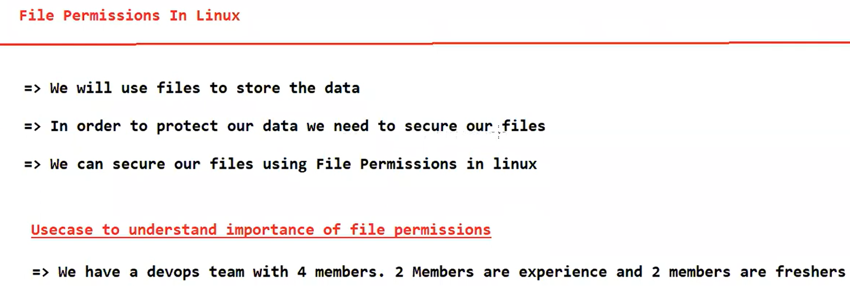

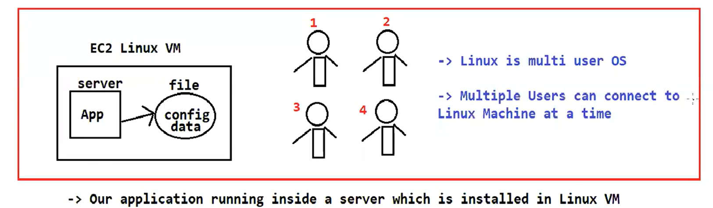

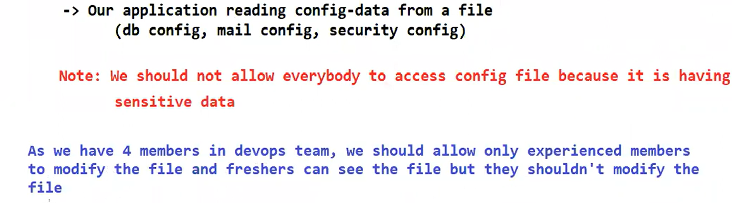

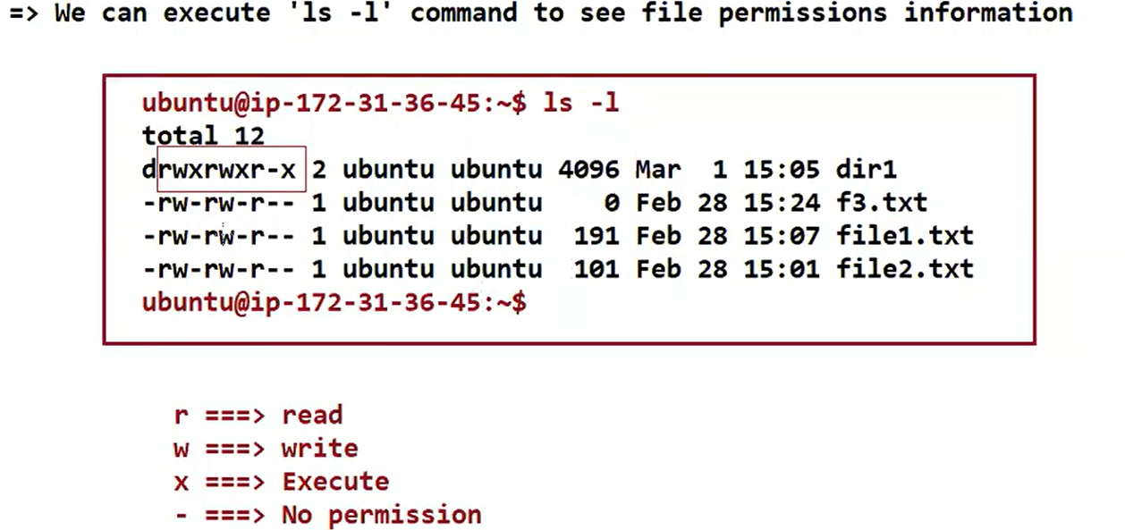

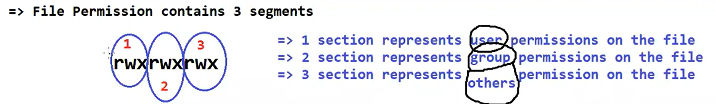

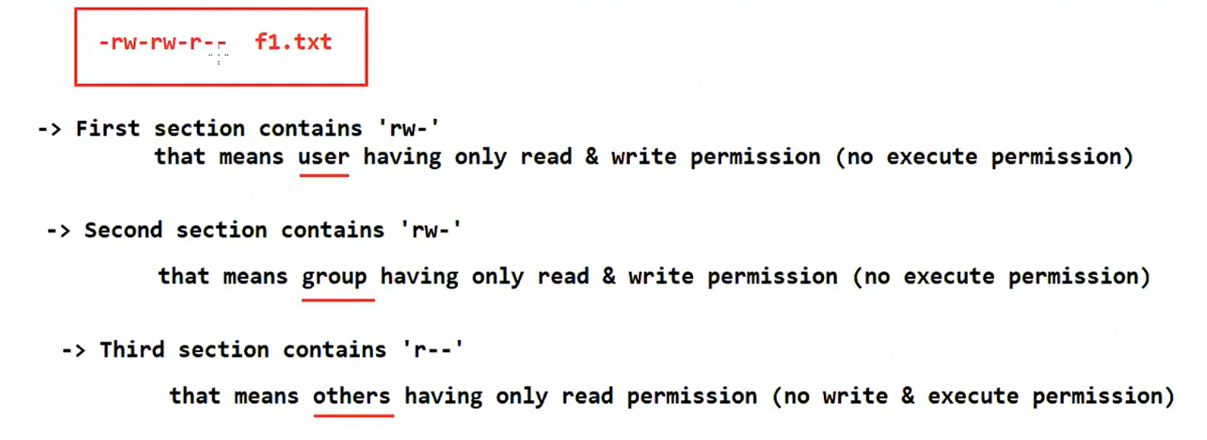

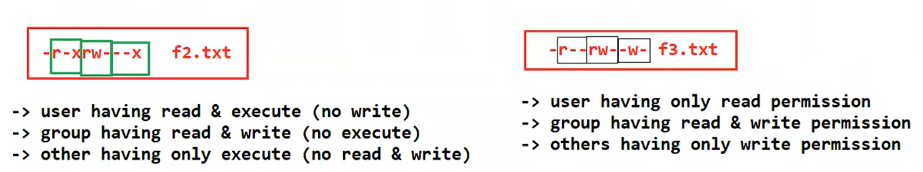

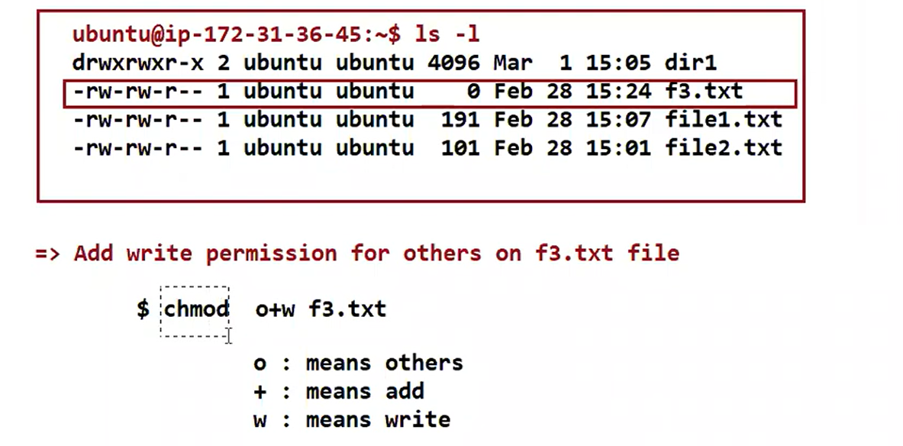

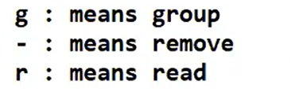

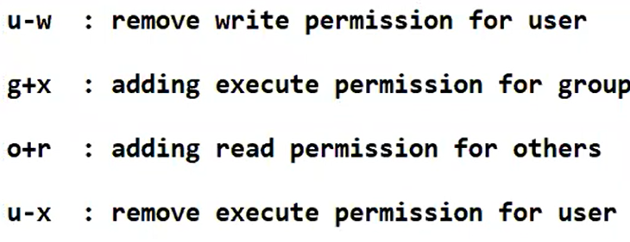

File permissions

================

To create a secure environment in Linux, you need to learn about user groups and permissions. For example, if you work in a company and you want the finance department to read a file but not make any modification to it, then you need to use permissions in Linux. It is a must for every programmer working with Linux nowadays.

Let’s start by talking about the ownership of Linux files.

User: the owner of the file (person who created the file).

Group: the group can contain multiple users.

Therefore, all users in that group will have the same permissions. It makes things easier than assign permission for every user you want.

Other: any person has access to that file, that person has neither created the file, nor are they in any group which has access to that file.

=> Execute 'ls -l' command to file's permissions

We will work with this part “-rw-r–r–".

The characters mean:

‘r’ = read.

‘w’ = write.

‘x’ = execute.

‘-’ = no permission.

-rw-r--r--

-: It represents file

rw: User

r: Group

r: Other

As we see above, the empty first part means that it is a file. If it were a directory then it will be the letter “d” instead.

The second part means that the user “Home” has read and write permissions but he does not have the execute one.

The group and others have only the read permission.

Let’s change the permissions using the chmod command.

$ chmod o+w section.txt

This command will add the write permission for other users to my text file “section.txt”.

Now if you try to execute ls -l then you will see -rw-r--rw-

“o” refers to others, “g” for the group, “u” for the user, and “a” for all.

Now let’s add the execute permission to the user with:

$ chmod u+x section.txt

The permissions will be -rwxr--rw-

If you want to remove the permission, you can use the same method but with “-” instead of “+”.

For example, let’s remove the execute permission from the user by:

$ chmod u-x section.txt

And the permissions now are: -rw-r--rw-

Also, you can use Symbolic Mode to modify permissions like the following:

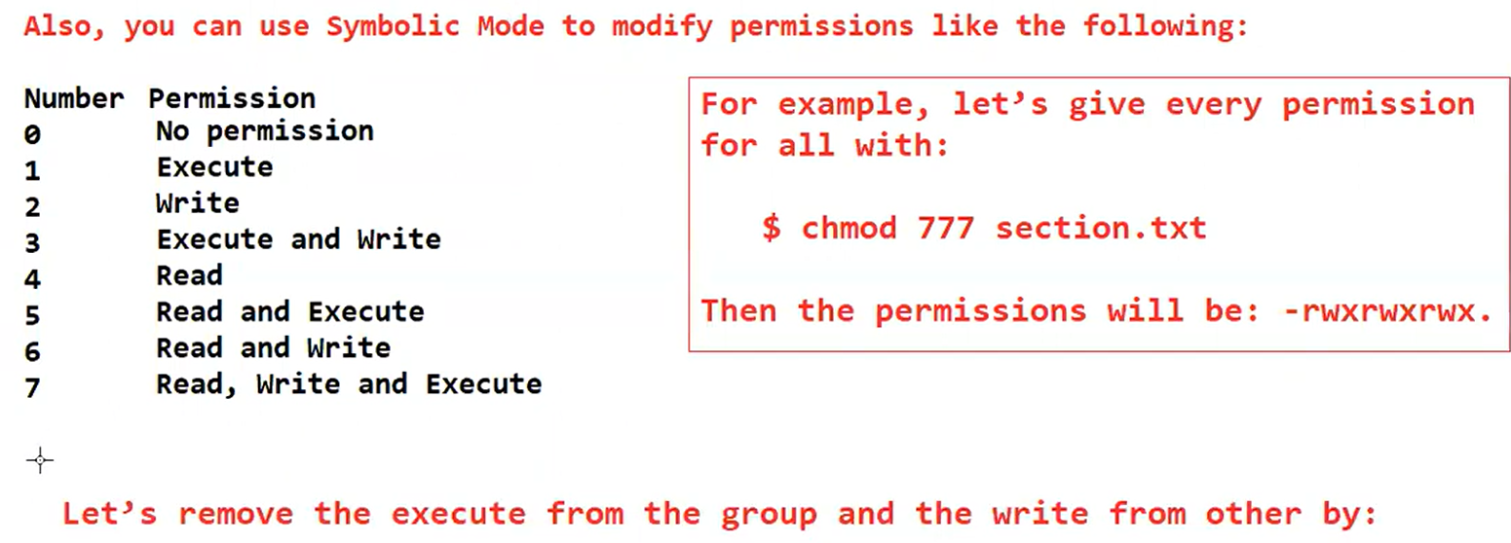

Number Permission

0 No permission

1 Execute

2 Write

3 Execute and Write

4 Read

5 Read and Execute

6 Read and Write

7 Read, Write and Execute

For example, let’s give every permission for all with:

$ chmod 777 section.txt

Then the permissions will be: -rwxrwxrwx.

Let’s remove the execute from the group and the write from other by:

$ chmod 765 section.txt

Then the permission will be : -rwxrw-r-x

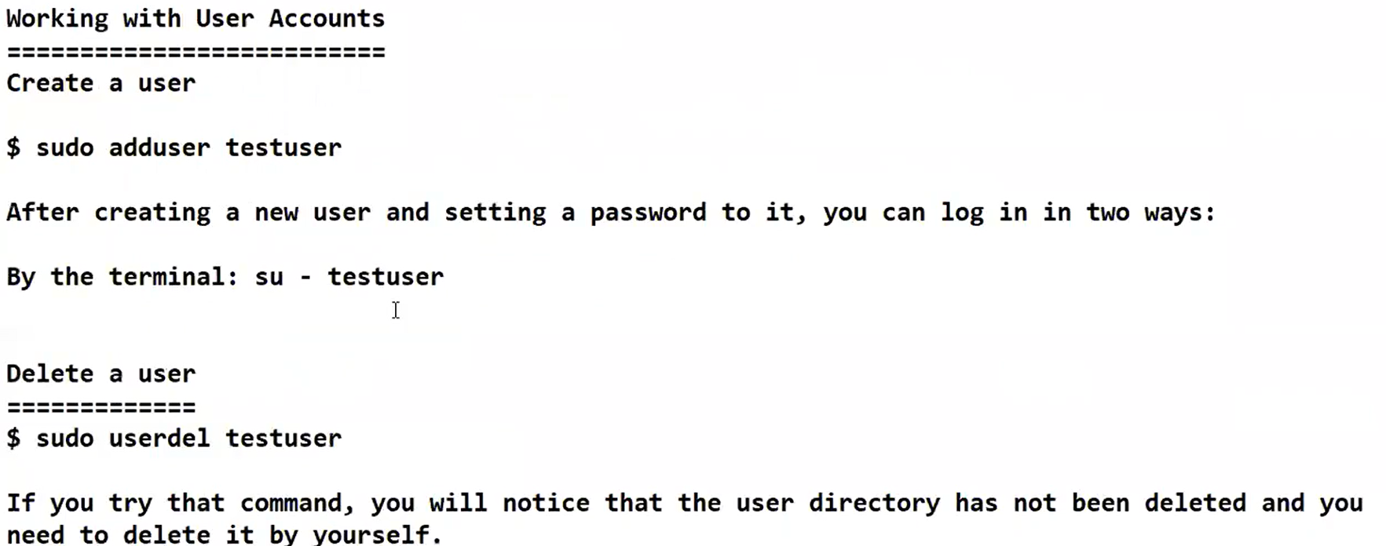

Working with User Accounts

==========================

=> Linux is multi user based operating systems

=> Within one Linux machine we can create multiple user accounts

=> Multiple users can access single linux machine and can perform multi-tasking

-> When we launch EC2 instance with Ubuntu OS, we got by default 'ubuntu' user account

Create a user

+++++++++++++

$ sudo adduser <uname>

=> After creating user account we can verify useraccount details using 'id' command

$ id <uname>

=> 'id' command will display user account information

=> Check the files available in home directory

$ ls -l

(We can see ubuntu folder and newly created user folder)

(That means we have 2 user accounts in our machine)

After creating a new user and setting a password to it, you can log in from the terminal

$ su - <uname>

Delete a user

=============

$ sudo userdel <uname>

If you try that command, you will notice that the user directory has not been deleted and you need to delete it by yourself.

You can use this automated command to do everything for you:

$ sudo deluser --remove-home <uname>

User groups

============

-> A group is a collection of users.

-> The primary purpose of the groups is to define a set of privileges like read, write, or execute permission for a given resource that can be shared among the users within the group.

Create a group

---------------

You can see all of the groups you have by opening the following file:

$ cat /etc/group

Create a group

----------------

$ sudo groupadd <groupname>

Add user to a group

--------------------

$ sudo usermod -aG <group-name> <username>

-> verify user groups using command -> $ id username

Delete user from a group

-------------------------

$ sudo gpasswd -d <username> <groupname>

Delete a group

--------------

$ sudo groupdel <groupname>

Working with 'find' and 'locate' commands

------------------------------------------

locate command

++++++++++++++++

The locate Command find will search for data in local db

$ sudo apt install mlocate

$ locate apache

$ locate -c apache

$ locate -c *.txt

$ locate -S (to see locate database)

Note: when we create new files it will take some time to update those files in mlocate db

find command

+++++++++++++

=> find command will search for the files in entire linux file system.

=> find command providing advanced searching technique

=> Using find command, we can search for the files based on name and type also.

2. Find Files Under Home Directory

# find /home -name f1.txt

7. Find Files With 777 Permissions

# find . -type f -perm 0777 -print

19. Find all Empty Files

# find /home -type f -empty

20. Find all Empty Directories

# find /home -type d -empty

Note: As find command is scanning entire file system, it will take more time to give search results.

----------------------------------------------------------------------------------------------

-> 'man' command is like a help command. It is used to understand command syntax and options.

$ man cat

-----------------------------------------------------------------------------------------------

-> To see ip address we will use 'ifconfig' command

$ ifconfig

Note : ifconfig is not installed then execute below command

$ sudo apt install net-tools

-> 'ping' command is used to check connectivity

$ ping <ip>

-> 'curl' command is used to get response from the server

$ curl <url>

-> 'wget' command is used to download resources from internet

$ wget <url>

-----------------------------------------------------------------------------------------------

Installing Apache Server In Ubuntu

==================================

1) Connect to EC2 instance (UBUNTU OS)

2) Execute below commands to install apache server

$ sudo su

$ sudo apt update

$ sudo apt install apache2

$ apache2 -version

$ sudo systemctl start apache2

$ sudo systemctl status apache2

Note: Check accessing apache server from outside using system IP

-> If server is not accessible then create security group with http port open

-> Add security group for EC2 instance

-> After adding security group try accessing EC2 instance using IP

Ex: http://52.66.101.3/

-> You can modify html page content

$ cd /var/www/html

$ cat > index.html

<h1> Welcome to Ashok IT - Website</h1>

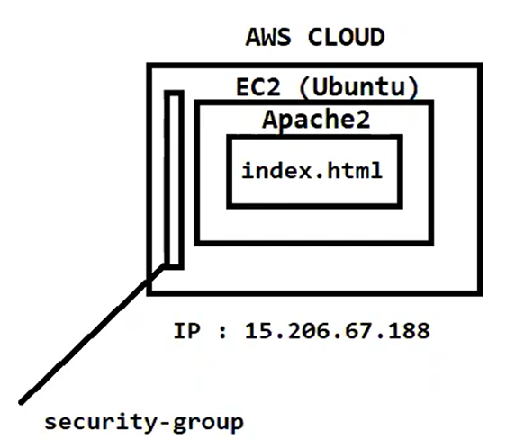

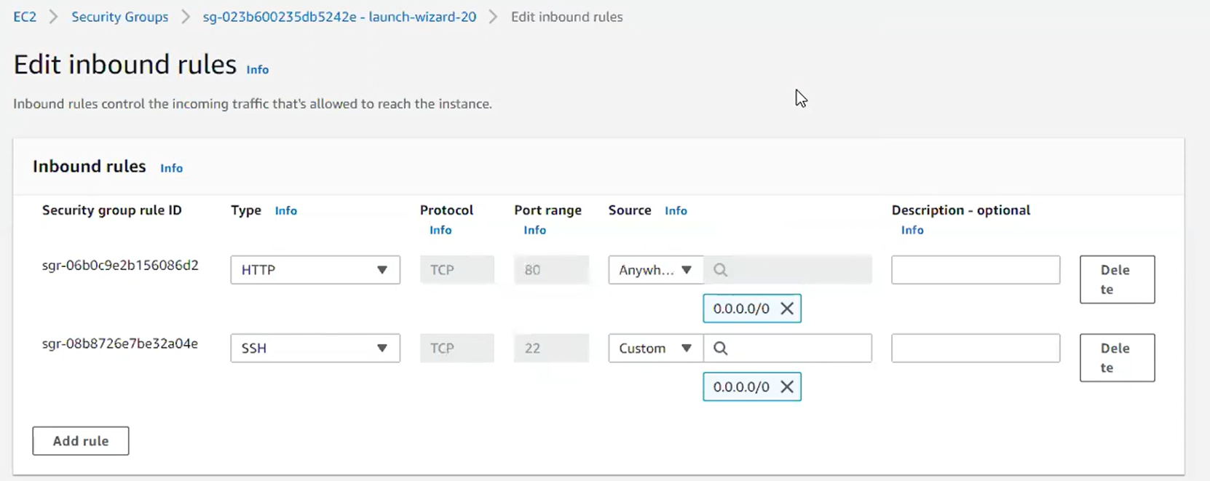

Deploying Website In EC2 Instance using WinSCP

===============================================

1) Download WinScp software (to transfer data from windows machine to Linux machine)

2) Keep index.html and assets in Ec2 - > Location : var/www/html

Note: If permission not available to store the data then execute below command

$ sudo chmod 777 /var/www/html -R

host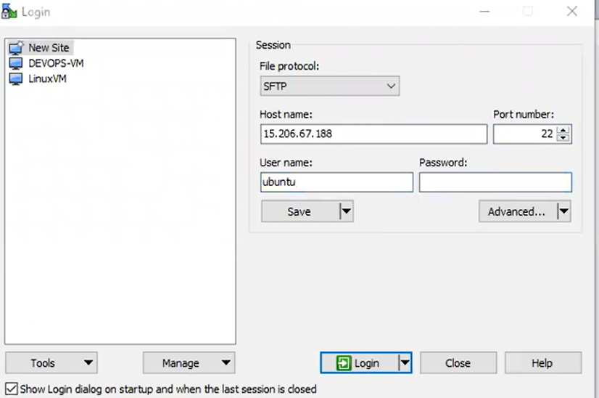

host name: linux ip ..

username :ec2-user

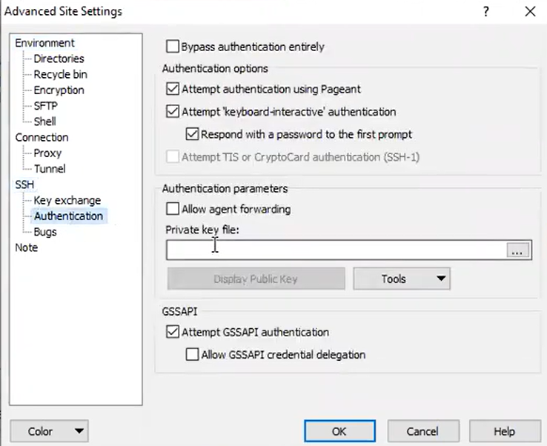

After press login button

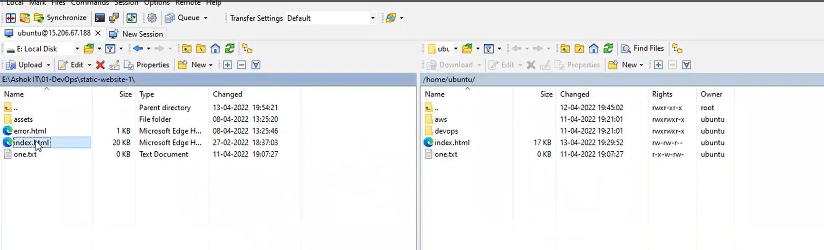

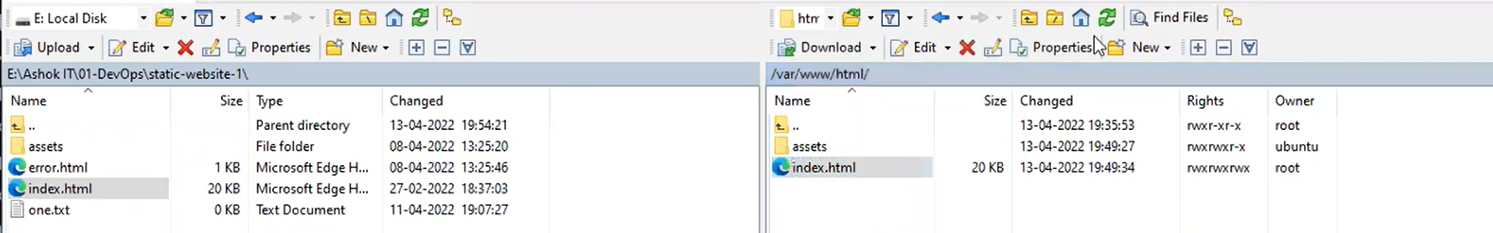

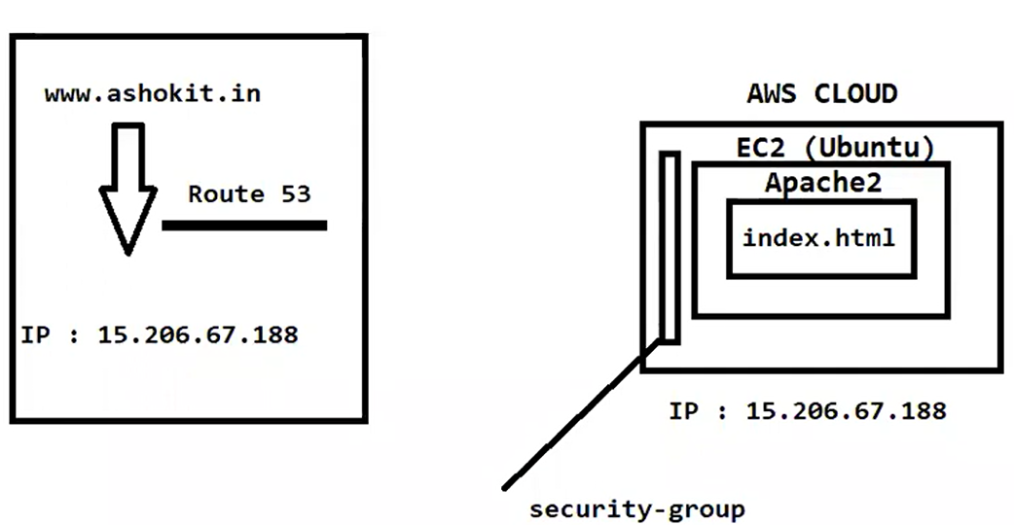

Ubantu -> root / var/www/html/

Install Java in Ubuntu

=======================

-> java -version (Check java version)

$ sudo su

$ sudo apt-get install default-jdk

Linux

Shell Scripting

